**ELC ACTIVITY SUBMISSION**

**Problem statement:**

To recognize the handwritten digits using KNN algorithm.

**Description of problem:**

Handwritten digit recognition presents a significant challenge in computer vision and artificial intelligence, despite considerable advancements in the field. Current systems often struggle with accurately and efficiently recognizing handwritten text due to the variability in handwriting styles and the complexity involved in identifying different shapes and sizes of handwritten numbers. This variability necessitates the development of robust systems capable of accurately recognizing handwritten text across various contexts such as forms, documents, and digital notes.

The objective of this project is to address the challenges of handwritten digit recognition by leveraging deep learning algorithms and image processing techniques. The goal is to develop an efficient and accurate system that provides a reliable solution for identifying handwritten digits, applicable to diverse real-world applications.

**Code and Explanation**

PART-I: Training the KNN Model

In this part, we train our K-nearest neighbours (KNN) classifier using different values of \( K \) (3, 5, 7, 9, 11) on a training dataset (`train.csv`).

PART-II: Testing the Trained Model

Here, we evaluate the trained models on a separate test dataset (`test.csv`). We compute and visualize the performance metrics such as precision, recall, F1 score, and confusion matrix for each \( K \) value.

Imported Modules Overview

1. Numpy: Essential for array operations, linear algebra, Fourier transforms, and matrix manipulations.
2. Pandas: Facilitates data handling tasks such as data analysis, cleaning, exploration, and manipulation within datasets.
3. Seaborn: Built on Matplotlib, Seaborn provides a high-level interface for creating visually appealing and informative statistical graphics.
4. Matplotlib: Comprehensive library for generating static, animated, and interactive visualizations in Python.

These modules collectively enable the implementation of the KNN classifier, evaluation of its performance metrics, and visualization of results, thereby supporting the development and assessment of the handwritten digit recognition system.

By iterating over multiple values of ( K ) and evaluating each model's performance rigorously, the project aims to identify the optimal ( K ) value that maximizes accuracy and other metrics for effective handwritten digit recognition.

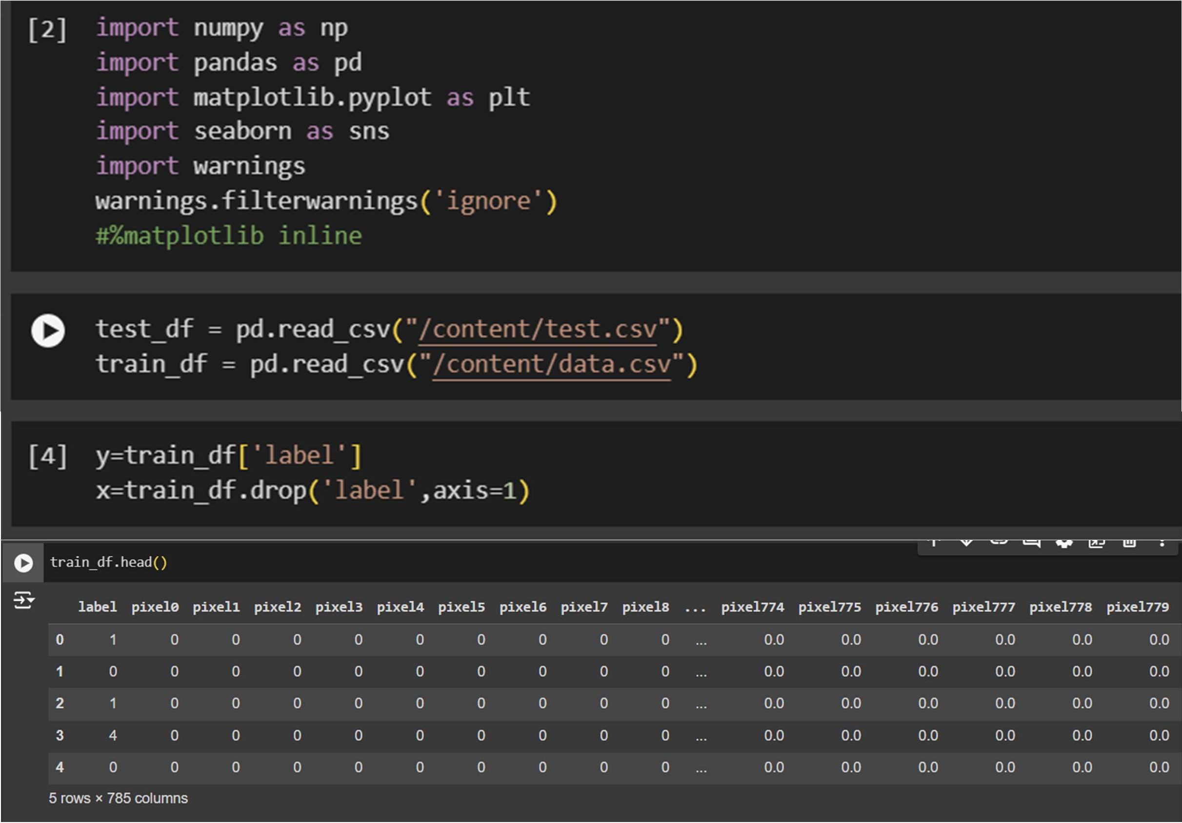

The code reads data from two distinct CSV files, namely "test.csv" and "train.csv", and stores the data in pandas data frames named test_df and train_df, respectively.

The pd.read_csv() function is a component of the pandas library in Python designed for reading CSV files into a pandas data frame. This function accepts the file path as its argument and returns a data frame containing the CSV file's data.

# To prepare data for supervised machine learning in handwritten text recognition:

The training data is organized within the train_df Data Frame, structured with two columns: label and pixels. The label column holds the ground truth label for each image in the training set, while the pixels column contains the pixel values representing each image.

The initial line of code extracts the label column from the train_df Data Frame and assigns it to the y_train

variable.

Following that, all columns except label are extracted from train_df and stored in the x_train variable. This separation results in two distinct variables: one holding the target values and the other containing the input features.

# To visualize the image data and validate its corresponding labels, the following code block is utilized:

1. The initial line configures the plot's size using `plt.figure()` with the `figsize` parameter.
2. The second line defines the variable `some_digit` to denote the index of the digit to be plotted, which here is set to 4.
3. The third line accesses the `some_digit` row from the training set using the `iloc` method and retrieves the `pixels` column as a NumPy array using `to_numpy()`.
4. The fourth line reshapes the 1D NumPy array into a 2D array of dimensions (28, 28), as each image is 28x28 pixels.
5. The fifth line employs `imshow()` from Matplotlib to plot the image.
6. The final line prints the label of the digit located at index `some_digit` from the `y_train` variable, thereby displaying the label corresponding to the handwritten digit image plotted.

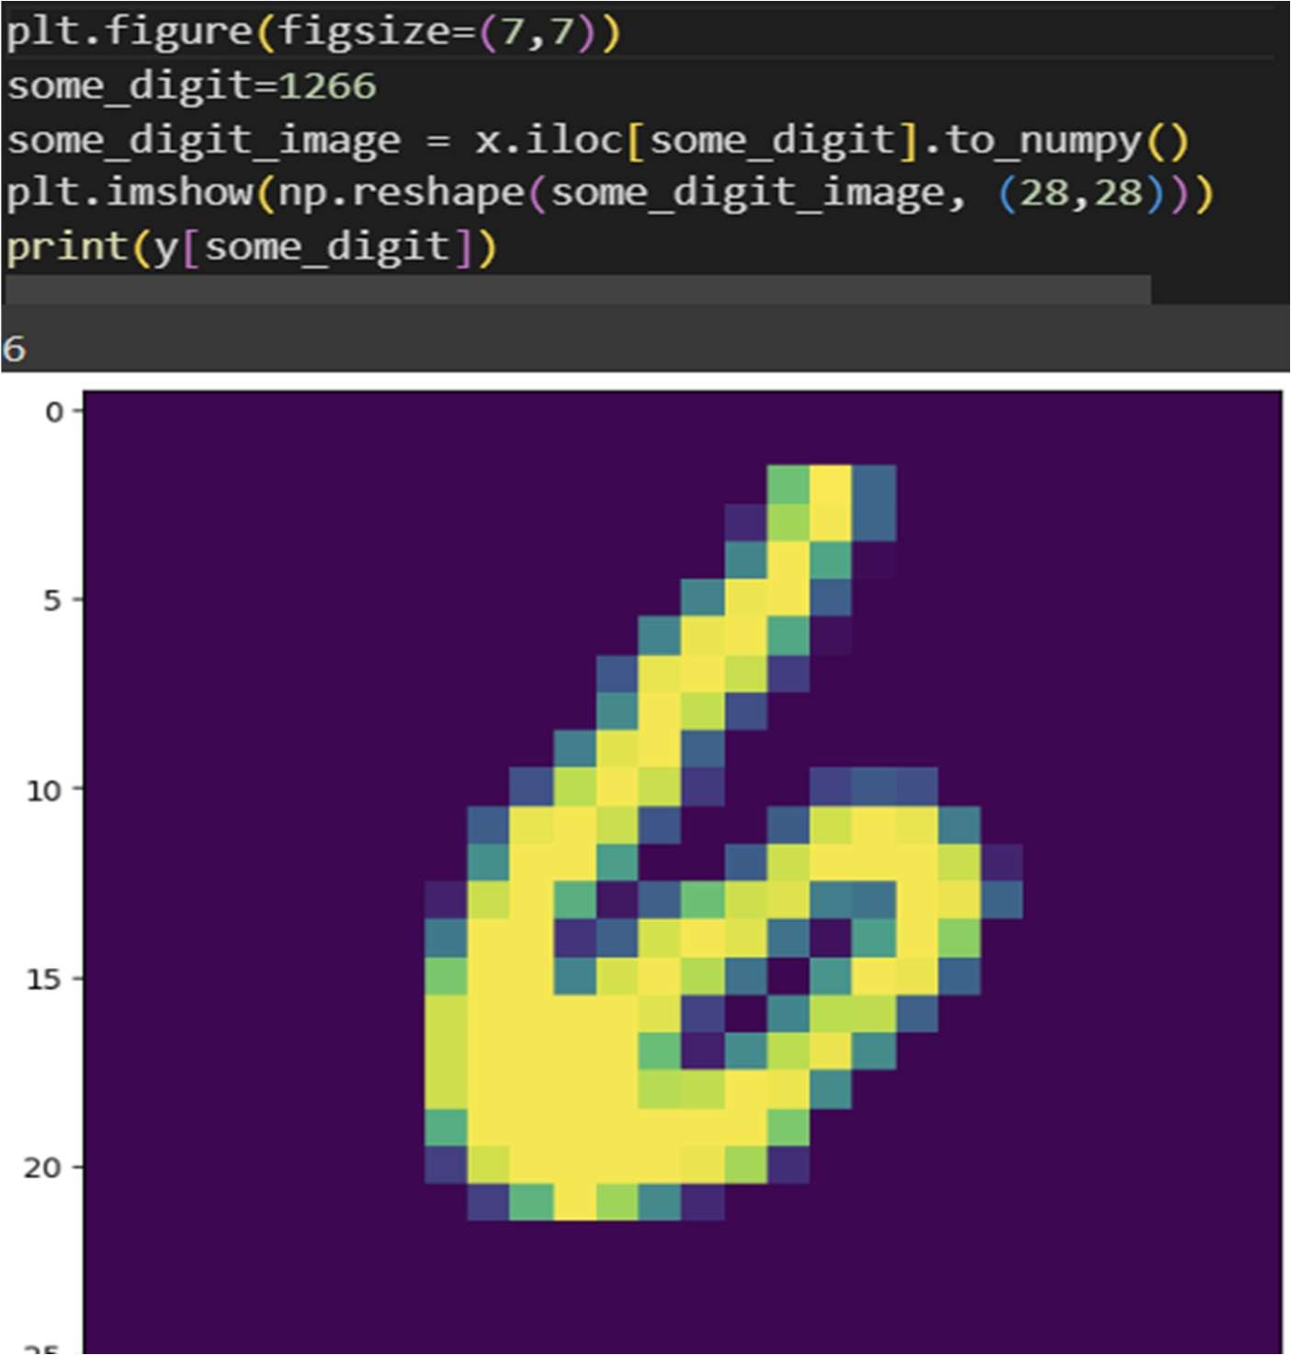

The code `sns.countplot(x='label', data=train_df)` utilizes the Seaborn library in Python to generate a countplot based on the `label` column in the `train_df` DataFrame.

A countplot is a type of bar plot that displays the frequency of each category in a categorical variable. Here, the `label` column serves as the categorical variable, and the countplot visually represents how often each category appears in the dataset. The `x` parameter specifies the column to be plotted along the x-axis, which in this case is `label`.

Assuming `train_df` is a Pandas DataFrame containing categorical data in the `label` column, executing this code will produce a bar plot where each category's count is shown on the y-axis, and the category names (labels) are displayed on the x-axis. This visualization is valuable for gaining insights into the distribution and frequency of different labels within the dataset.

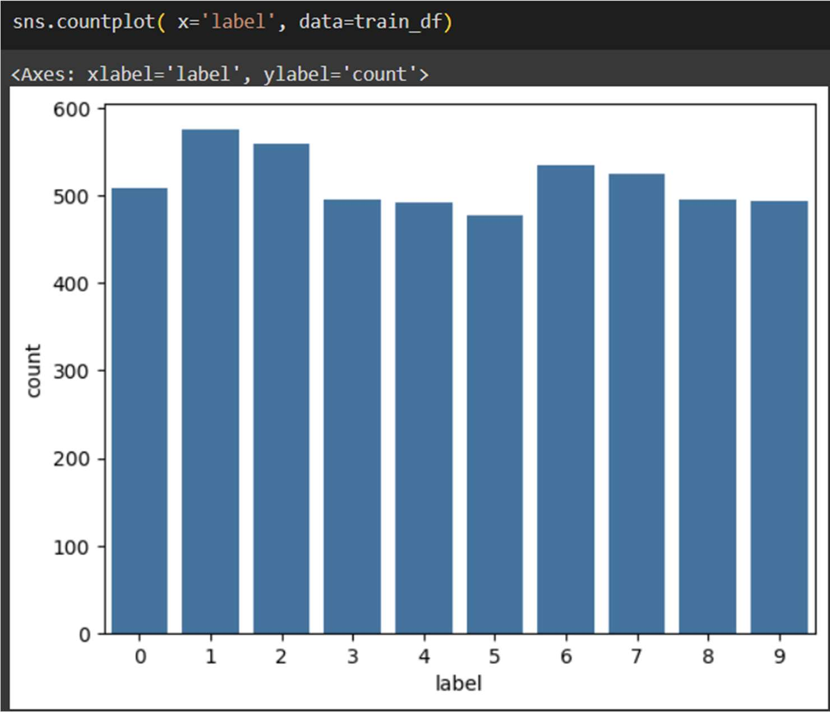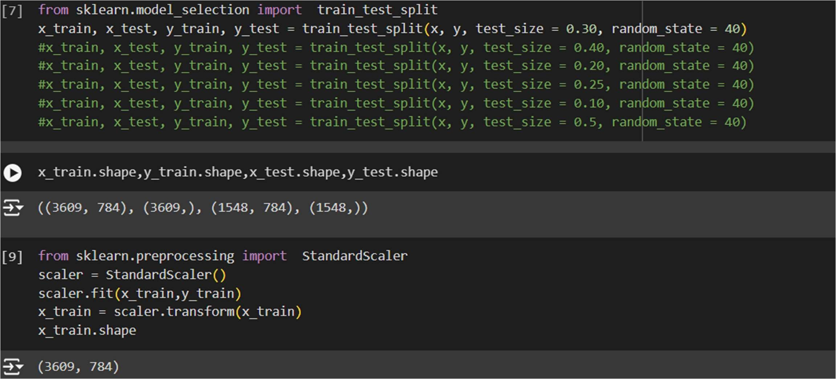

The following steps outline the training and evaluation process of a K-nearest neighbors (KNN) classifier using the handwritten digit dataset:

The first line imports the KNeighborsClassifier class from the sklearn.neighbors module. This class implements the KNN algorithm, which categorizes data points based on their nearest neighbors.

The third line creates an instance of the KNeighborsClassifier class with the n_neighbors parameter set to 3. This parameter determines the number of nearest neighbors considered for making classification decisions. It can be adjusted to experiment with different values of n_neighbors and evaluate their impact on model performance.

The sixth and seventh line fits the classifier to the training data using the fit() method of the KNeighborsClassifier class.

The eighth line uses the trained model to predict labels for the test set, storing the predicted labels in the y_pred variable.

The subsequent lines calculate and display the accuracy, classification report, and confusion matrix of the KNN classifier.

The accuracy_score() function from the sklearn.metrics module computes the accuracy of the model by comparing the predicted labels (y_pred) to the actual labels in the test set (y_test).

The classification_report() function generates a detailed report that includes precision, recall, and F1- score metrics for each class in the dataset.

The confusion_matrix() function calculates the confusion matrix, providing a breakdown of true positives, false positives, false negatives, and true negatives for each class.

These evaluations help assess the performance and effectiveness of the KNN classifier in recognizing handwritten digits based on the provided test dataset.

TEST_SIZE=0.3 AND TRAIN_SIZE=0.70

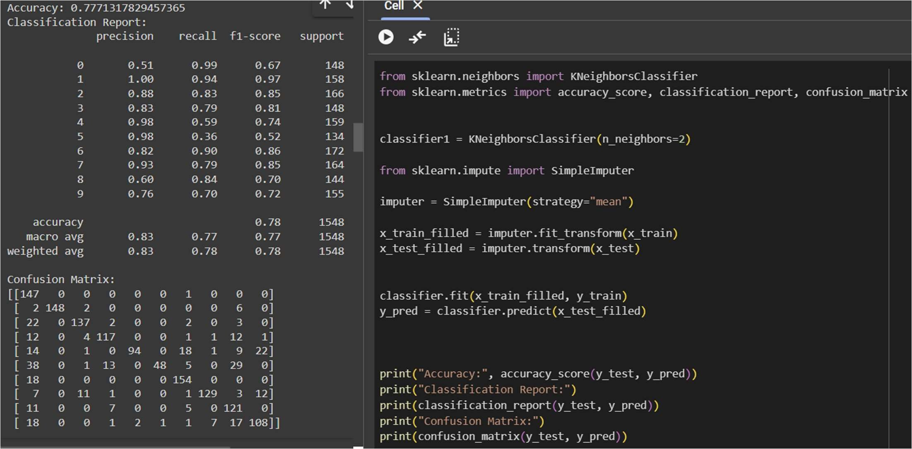

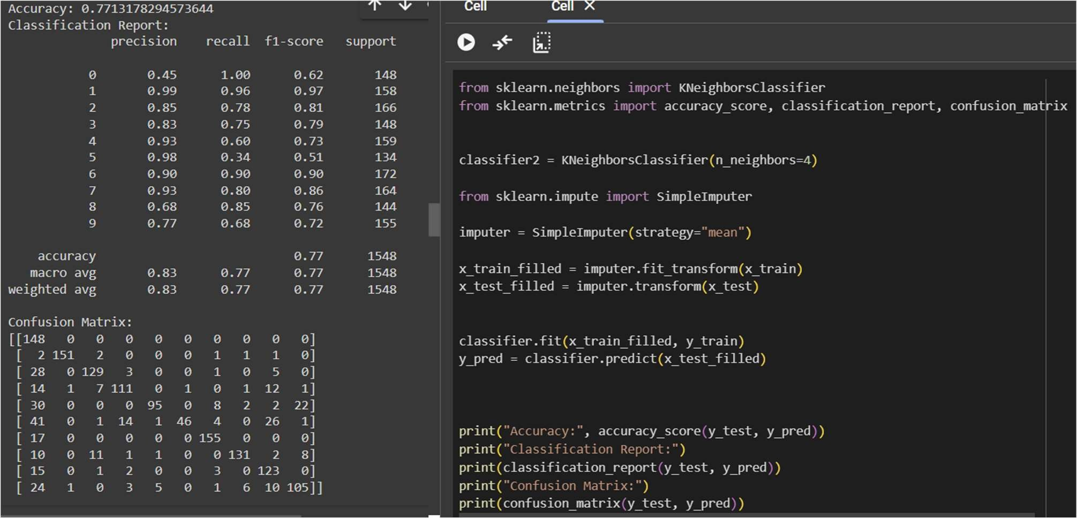

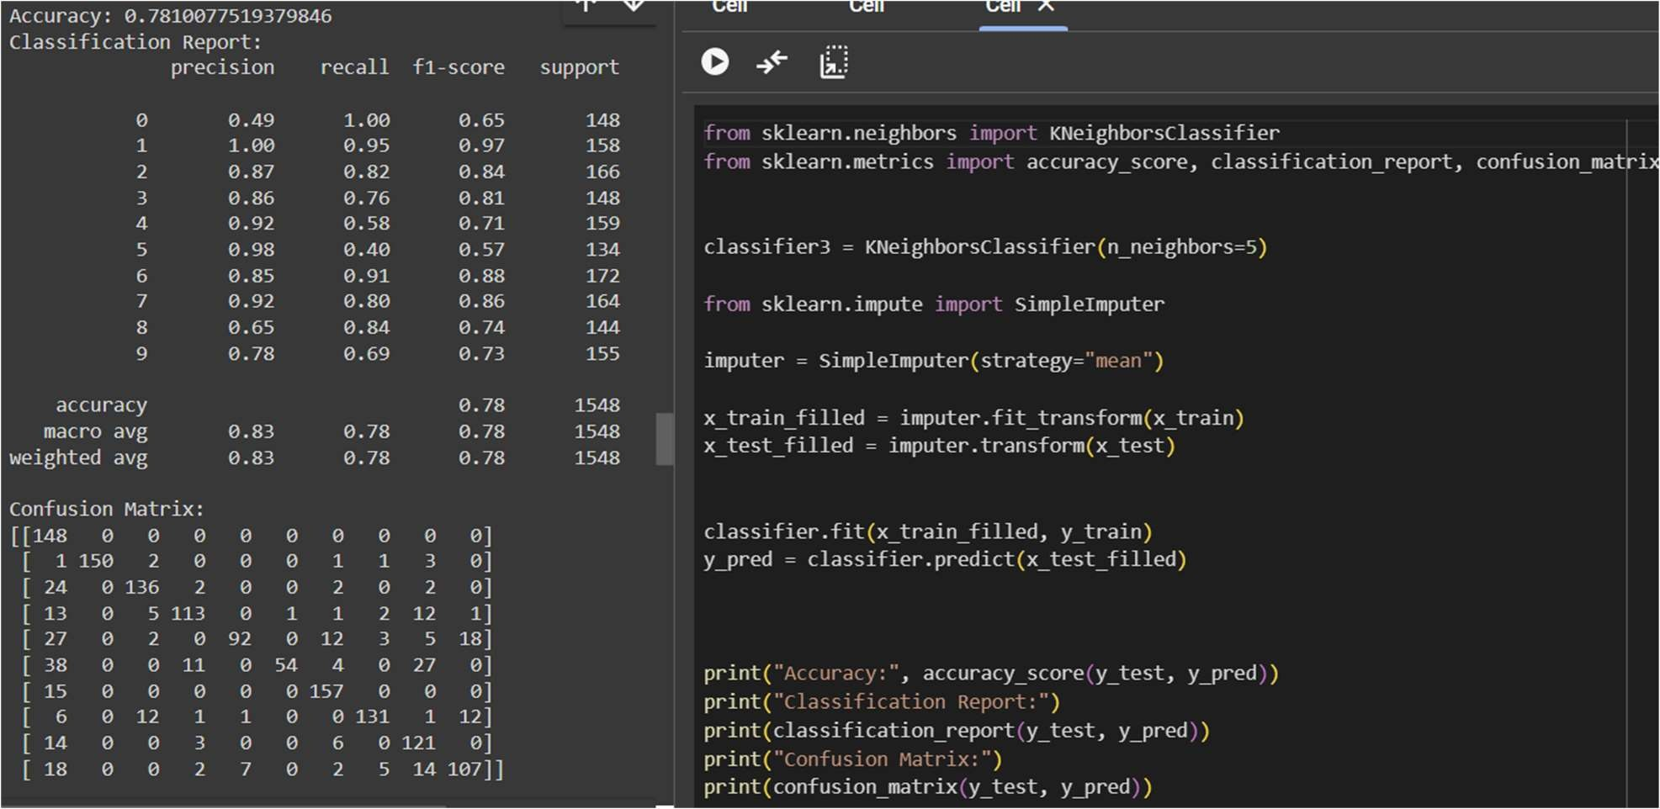

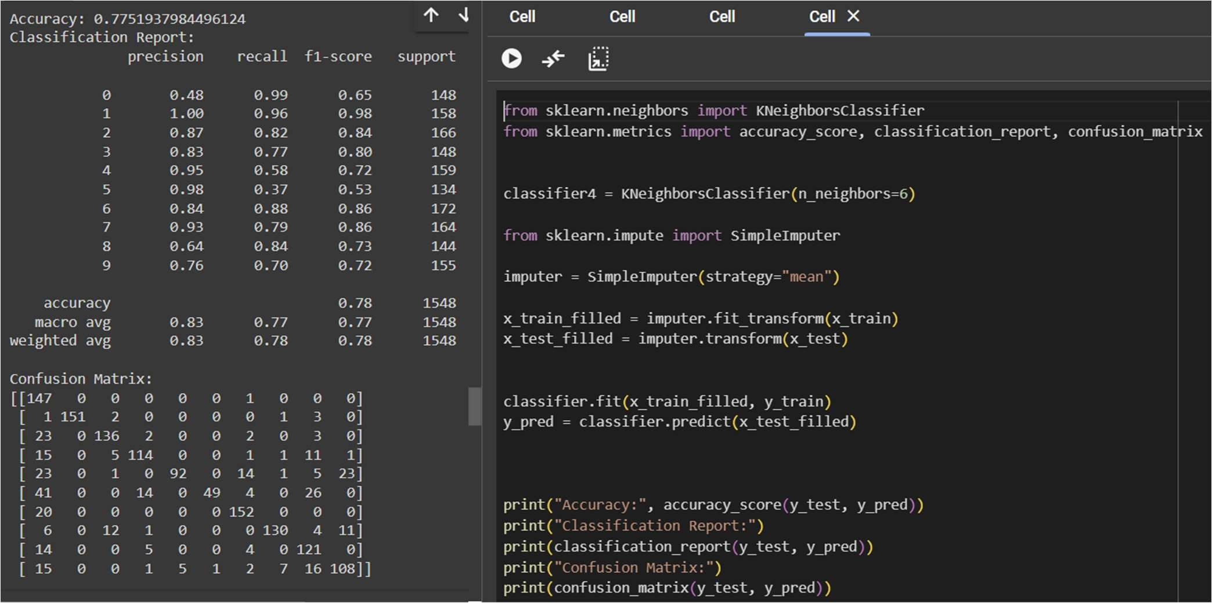

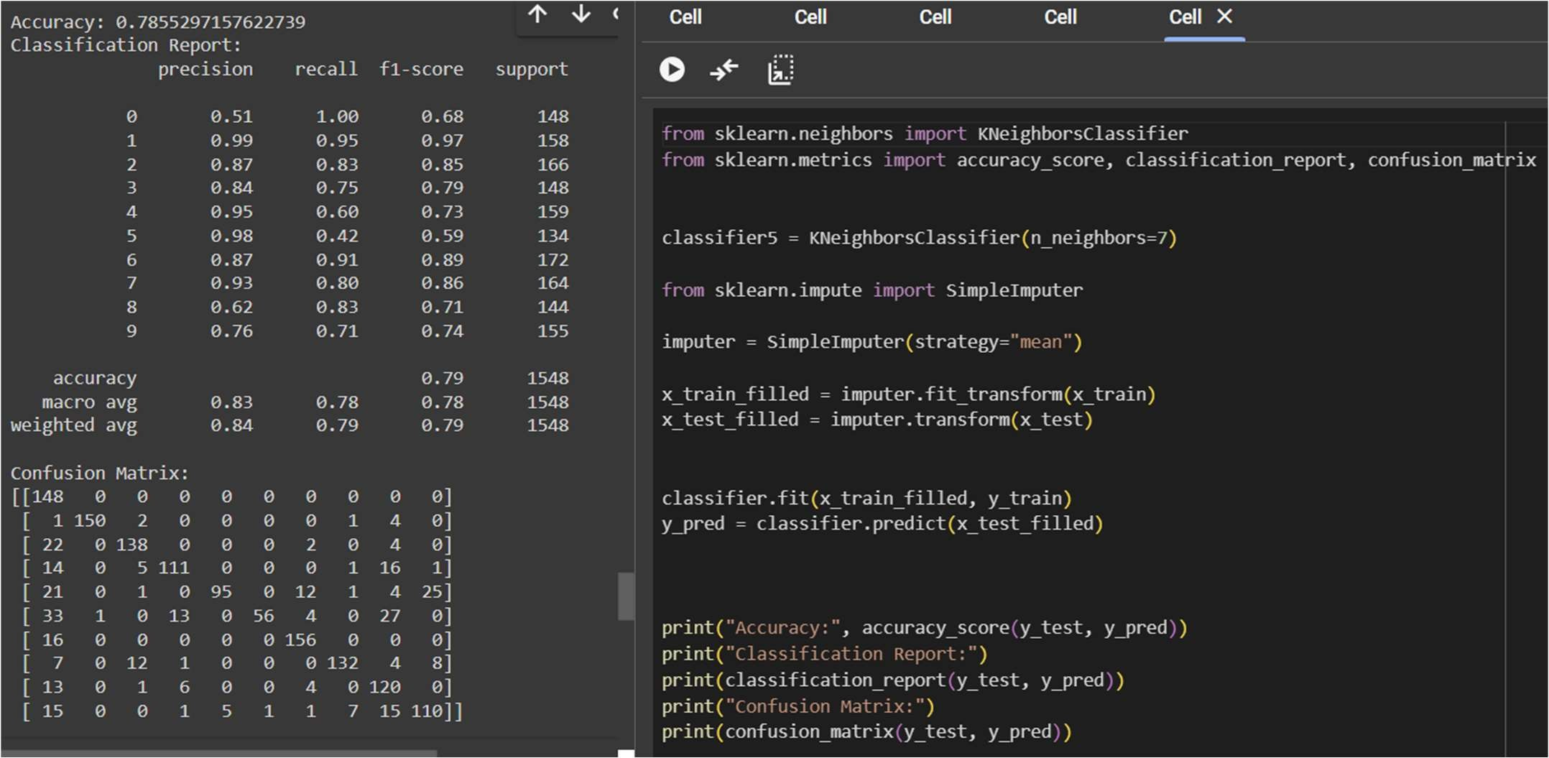

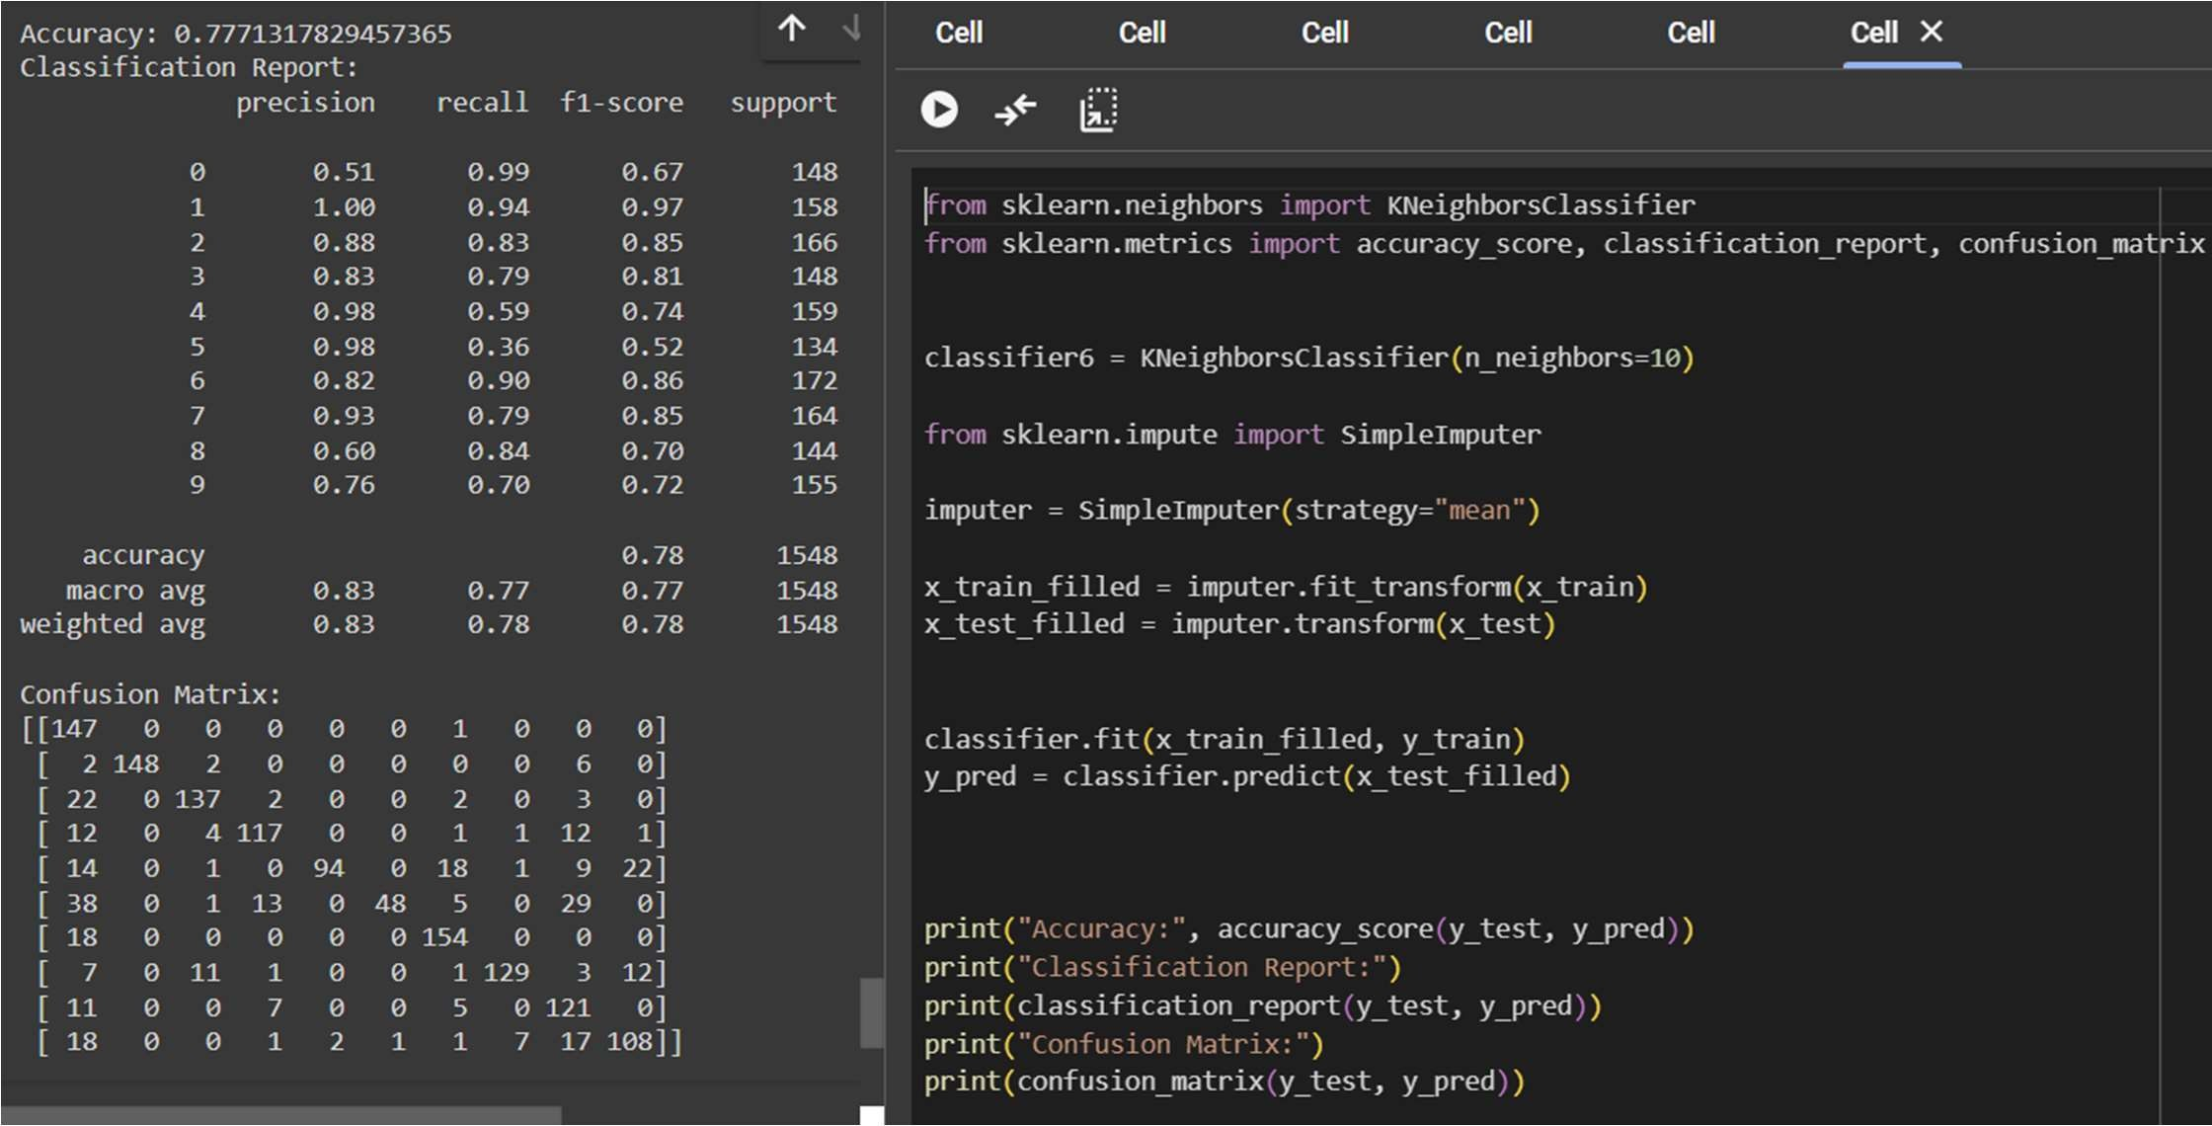

TEST_SIZE=0.40 AND TRAIN_SIZE=0.60

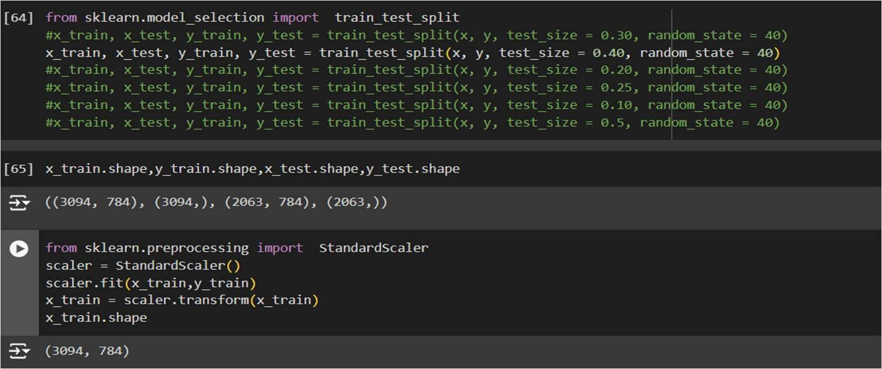

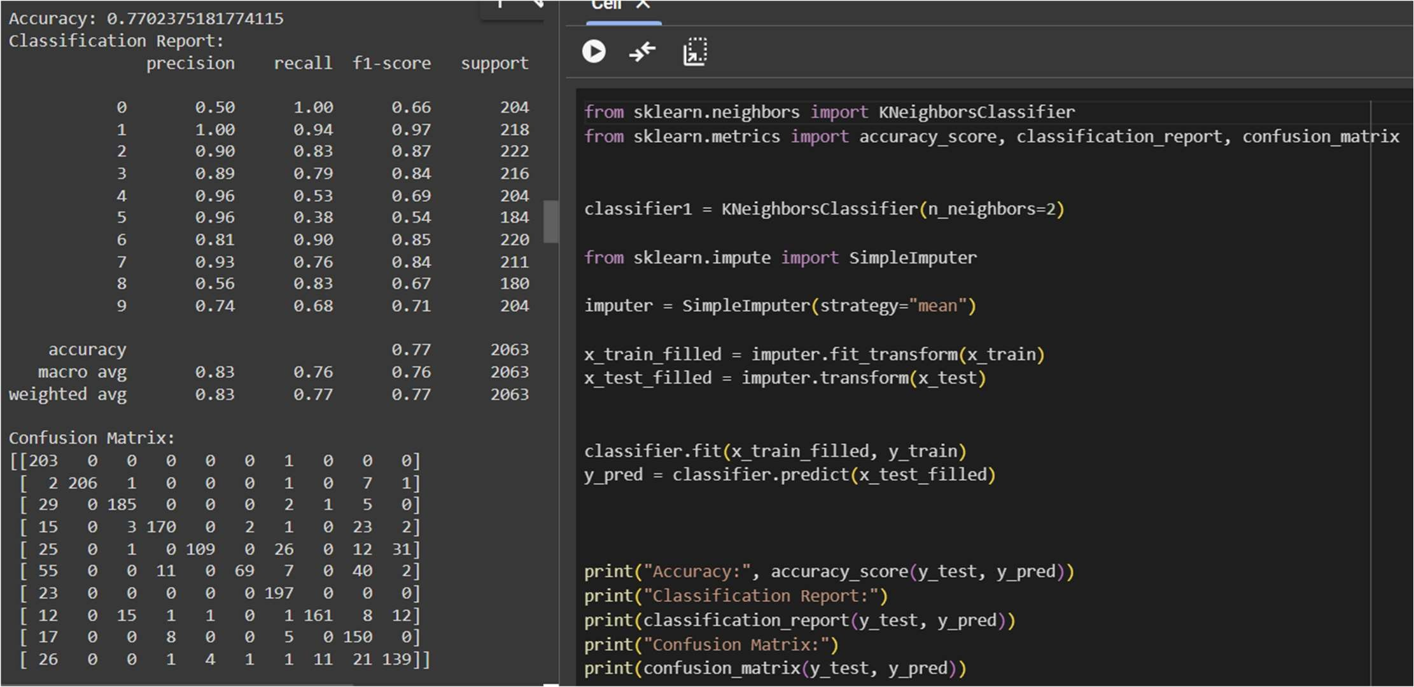

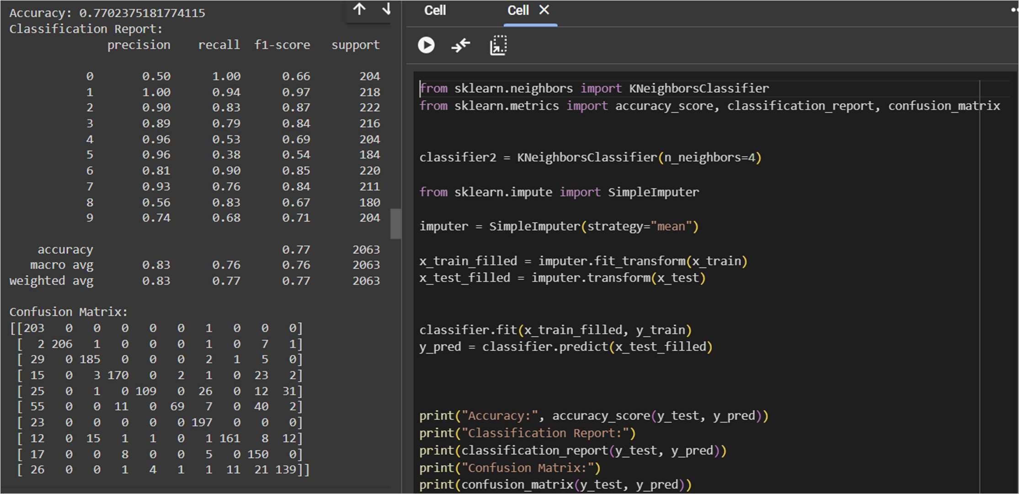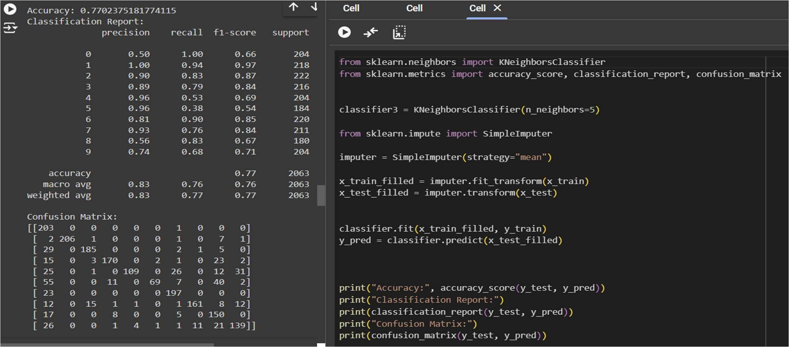

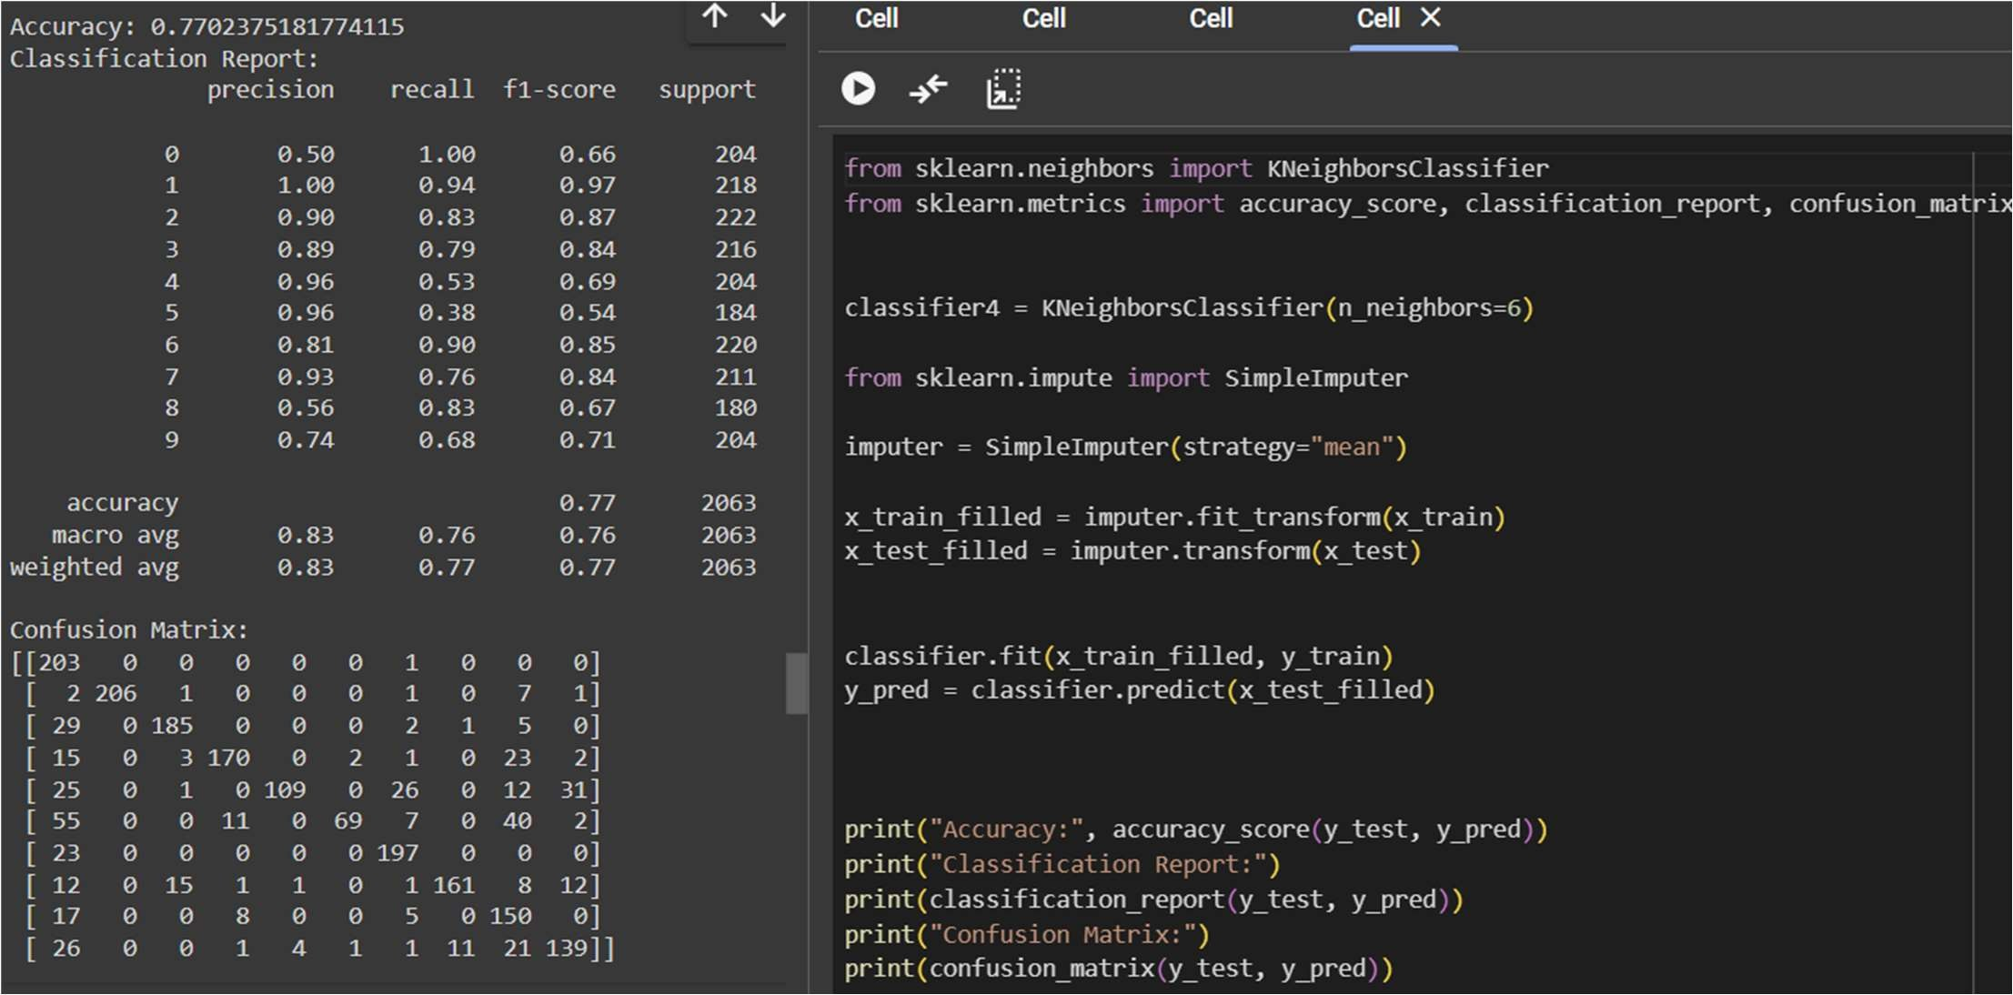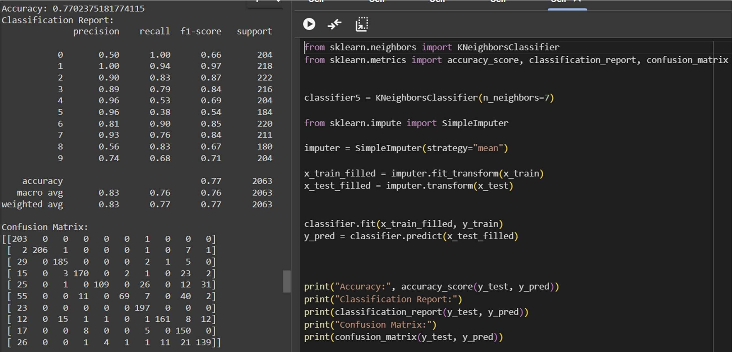

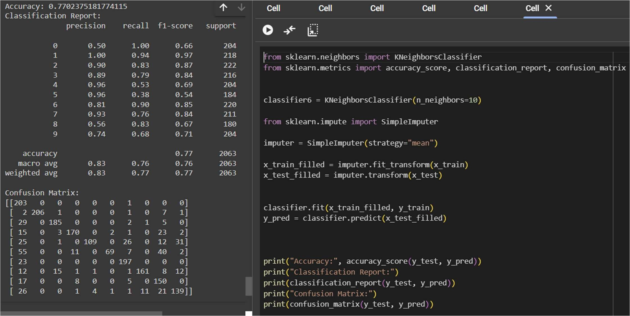

TEST_SIZE=0.20 AND TRAIN_SIZE=0.80

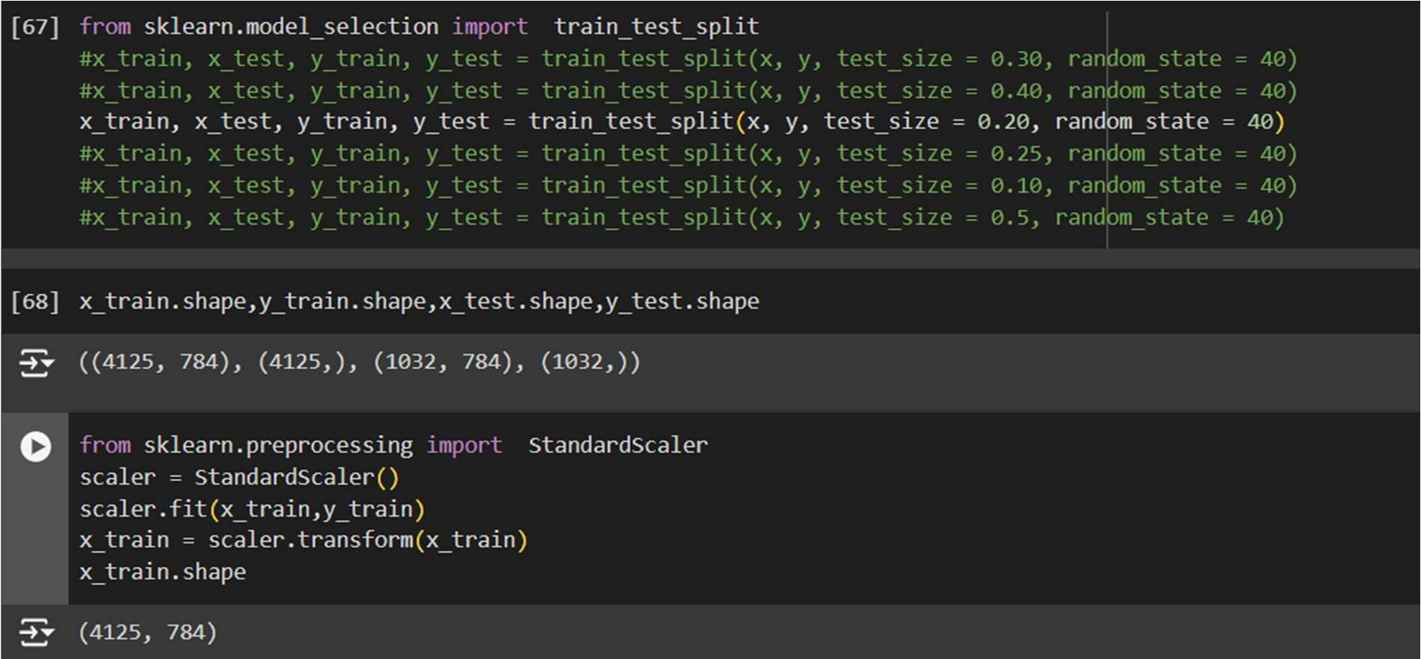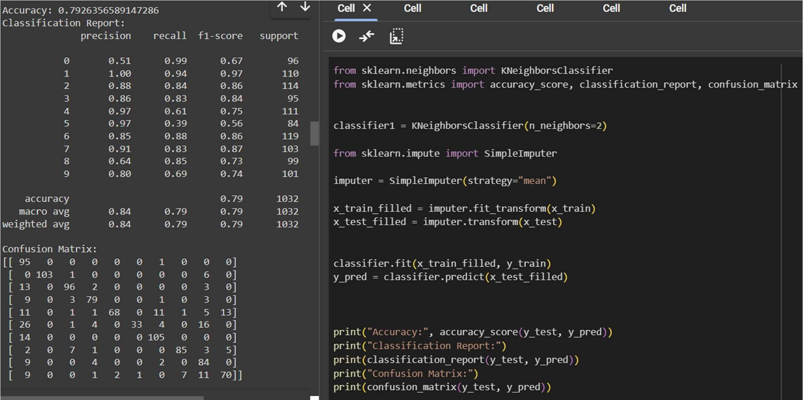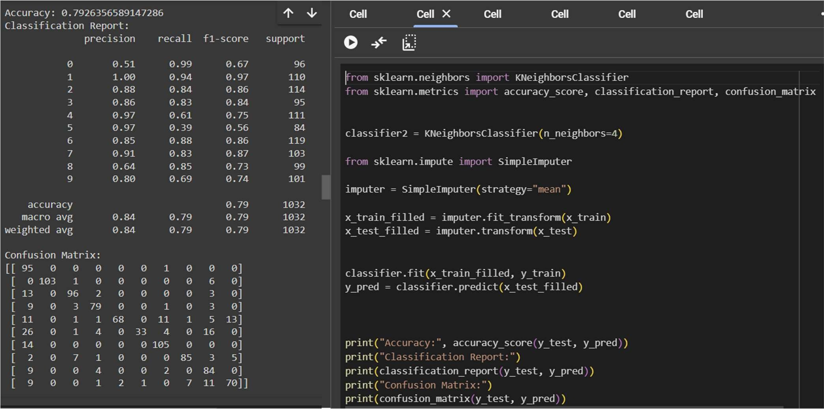

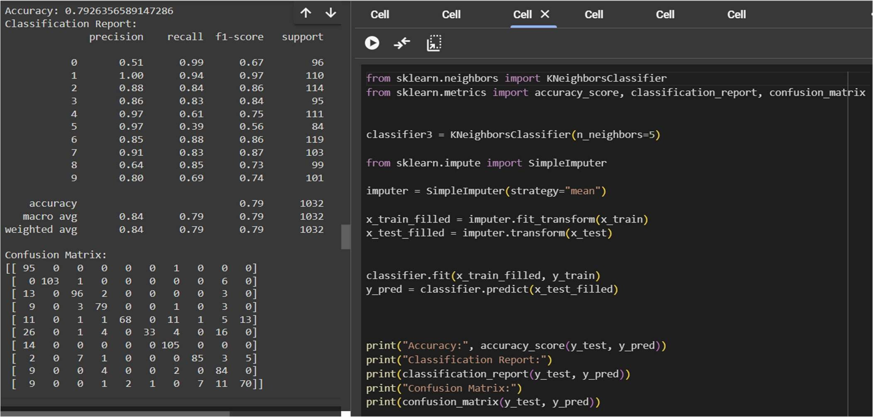

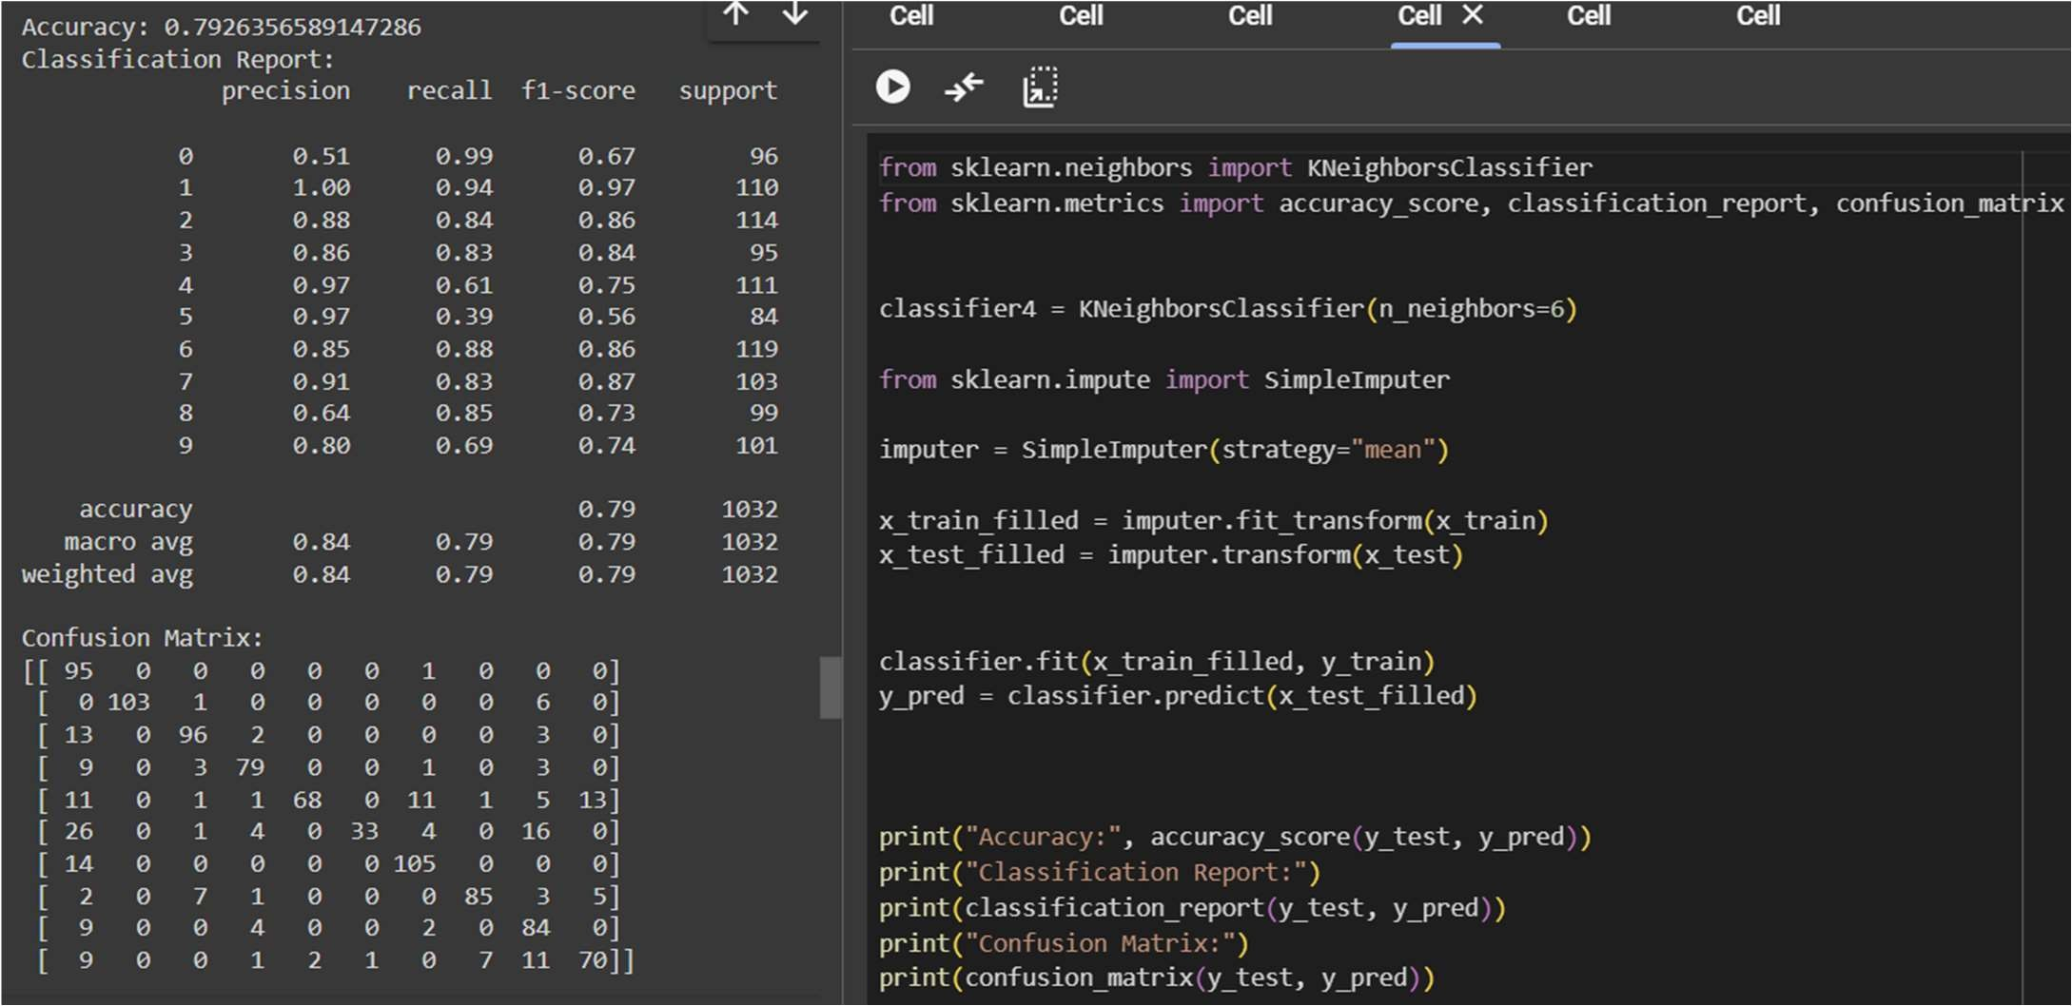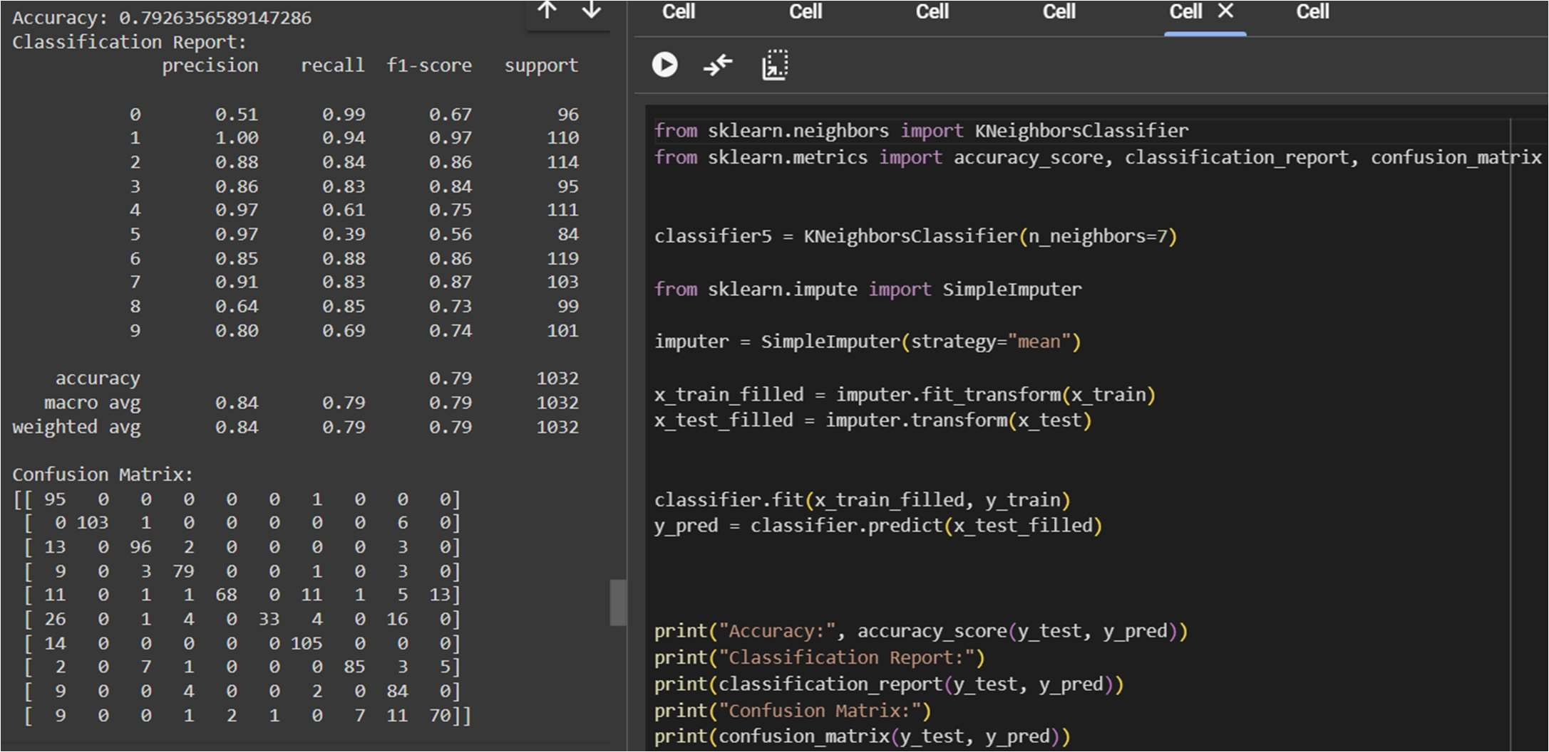

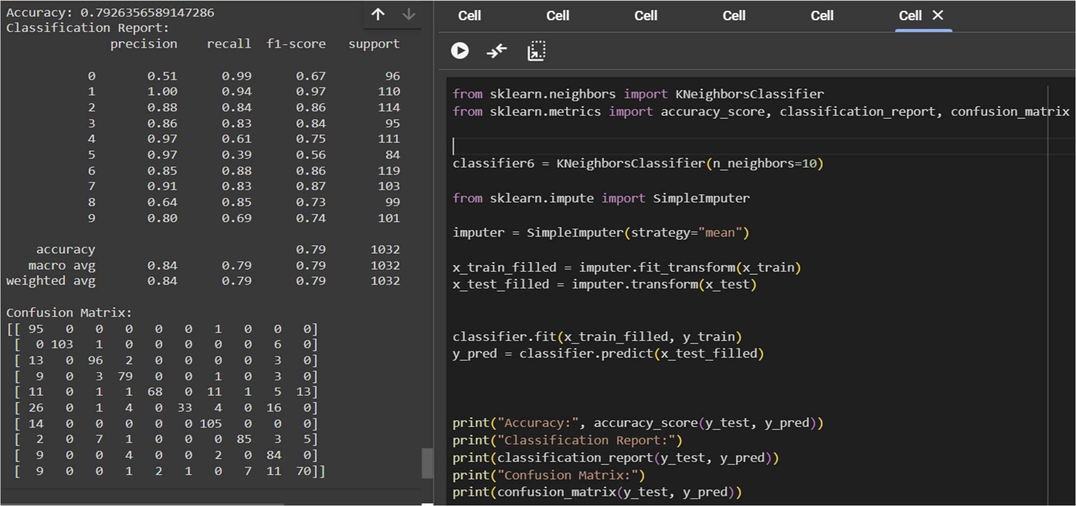

TEST_SIZE=0.25 AND TRAIN_SIZE=0.75

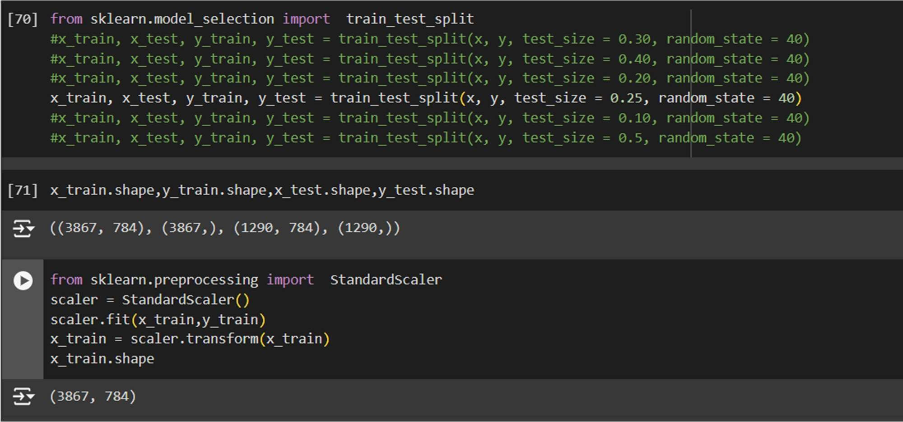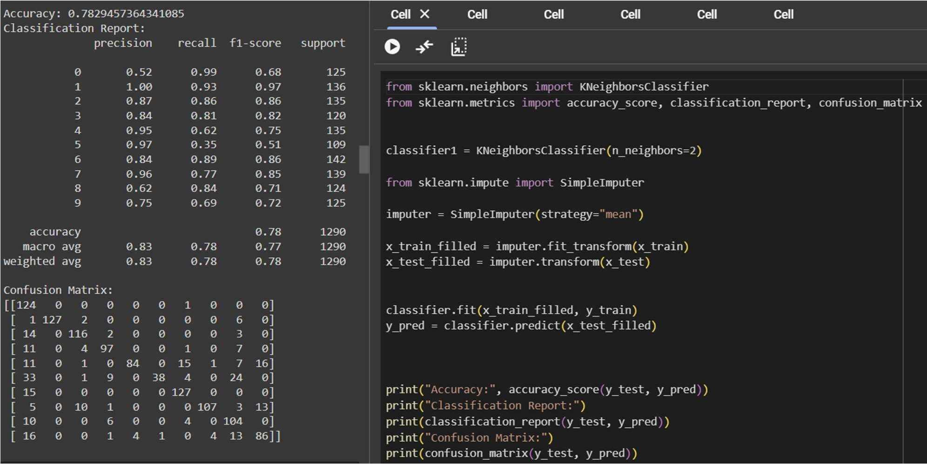

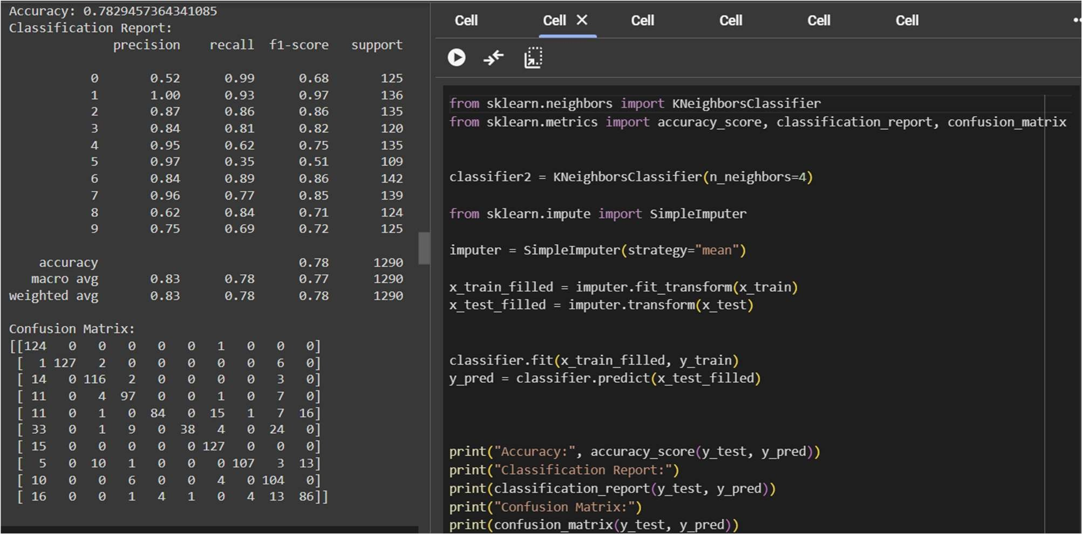

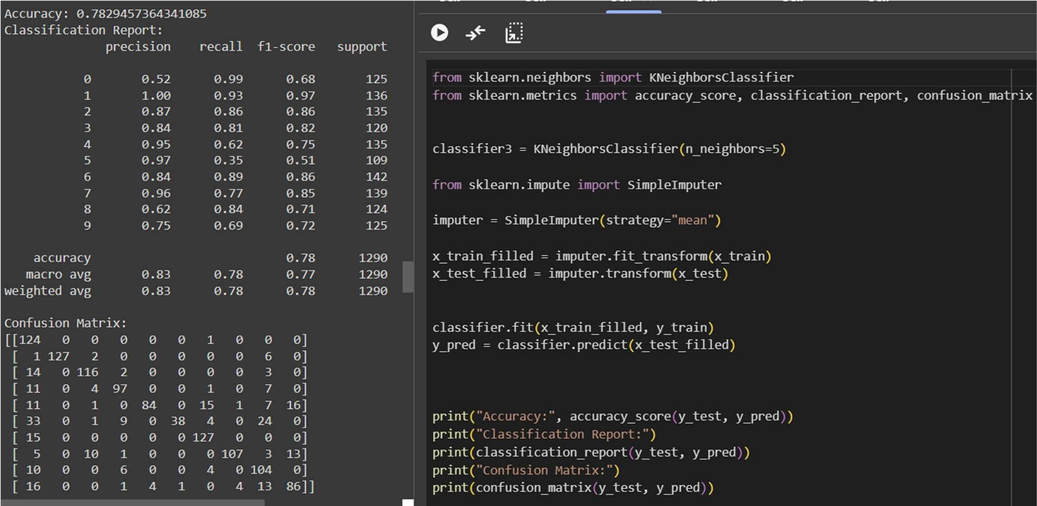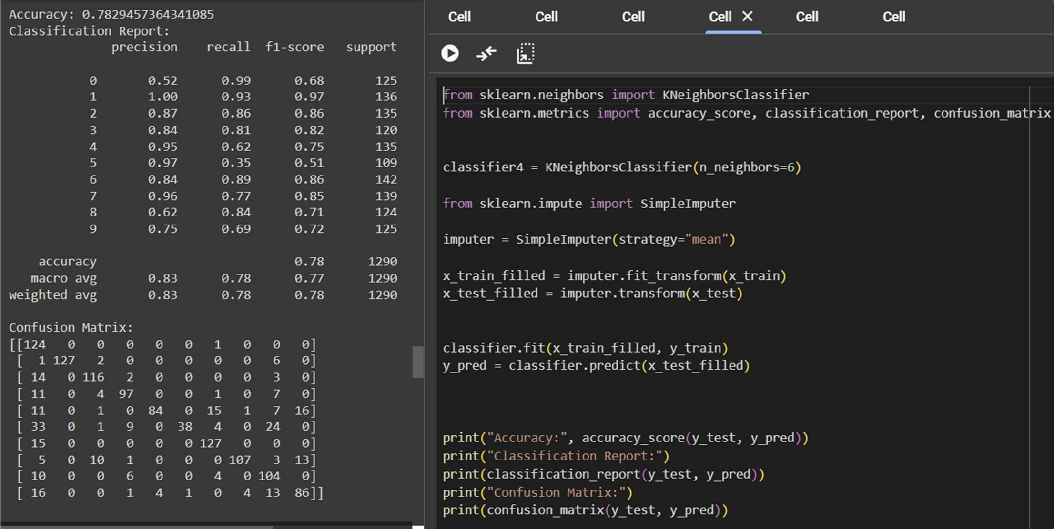

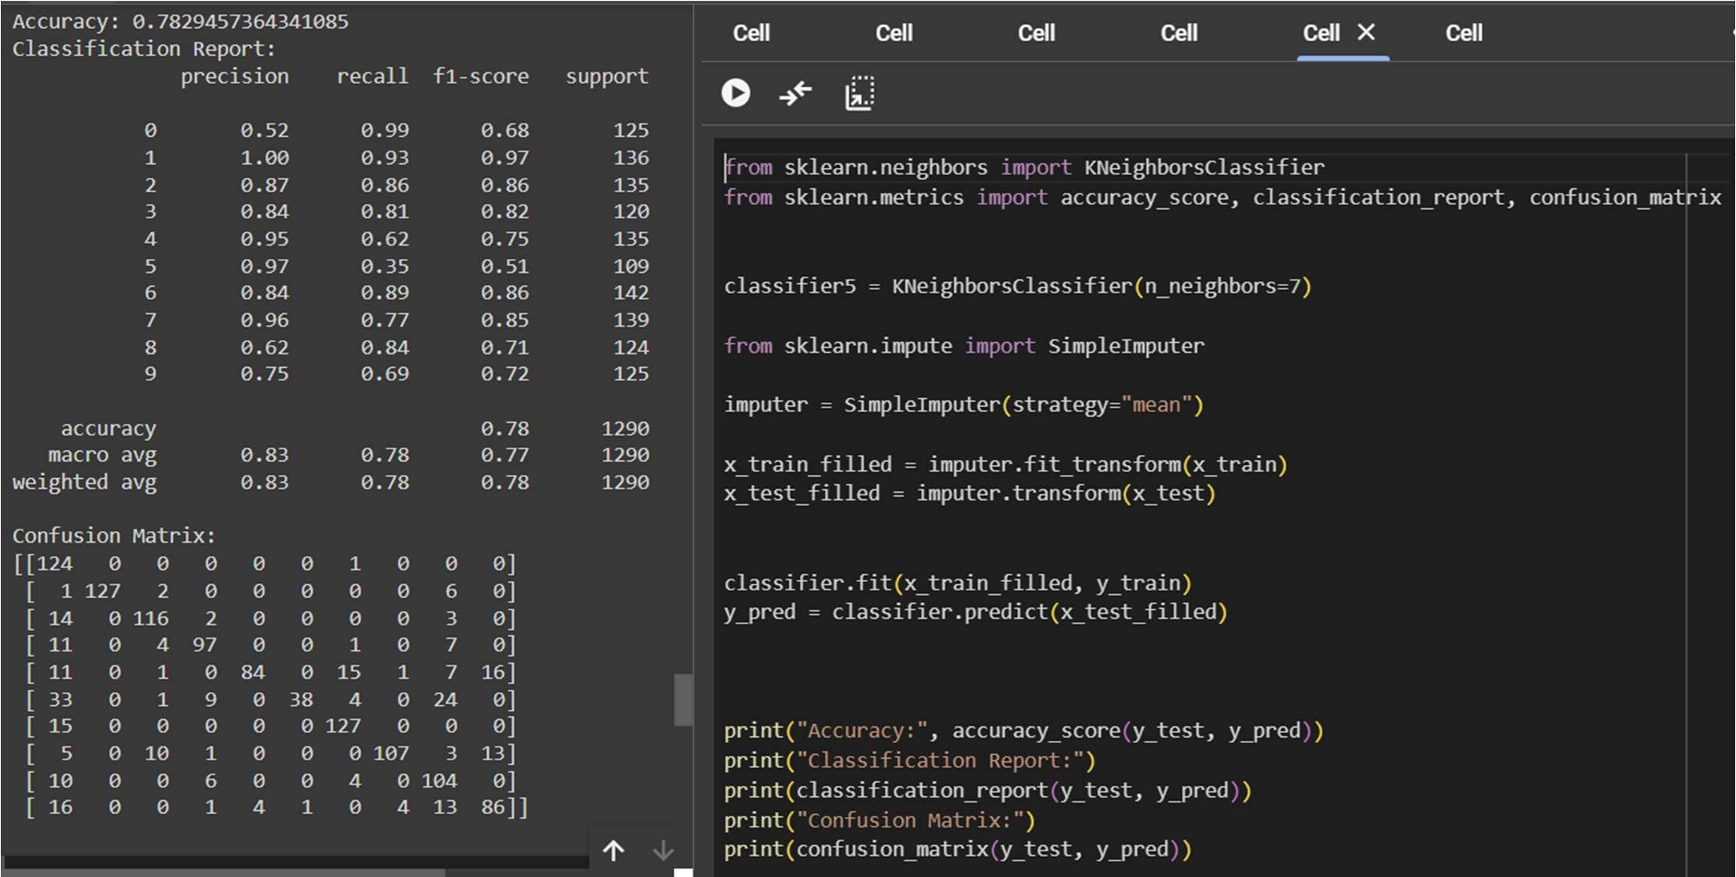

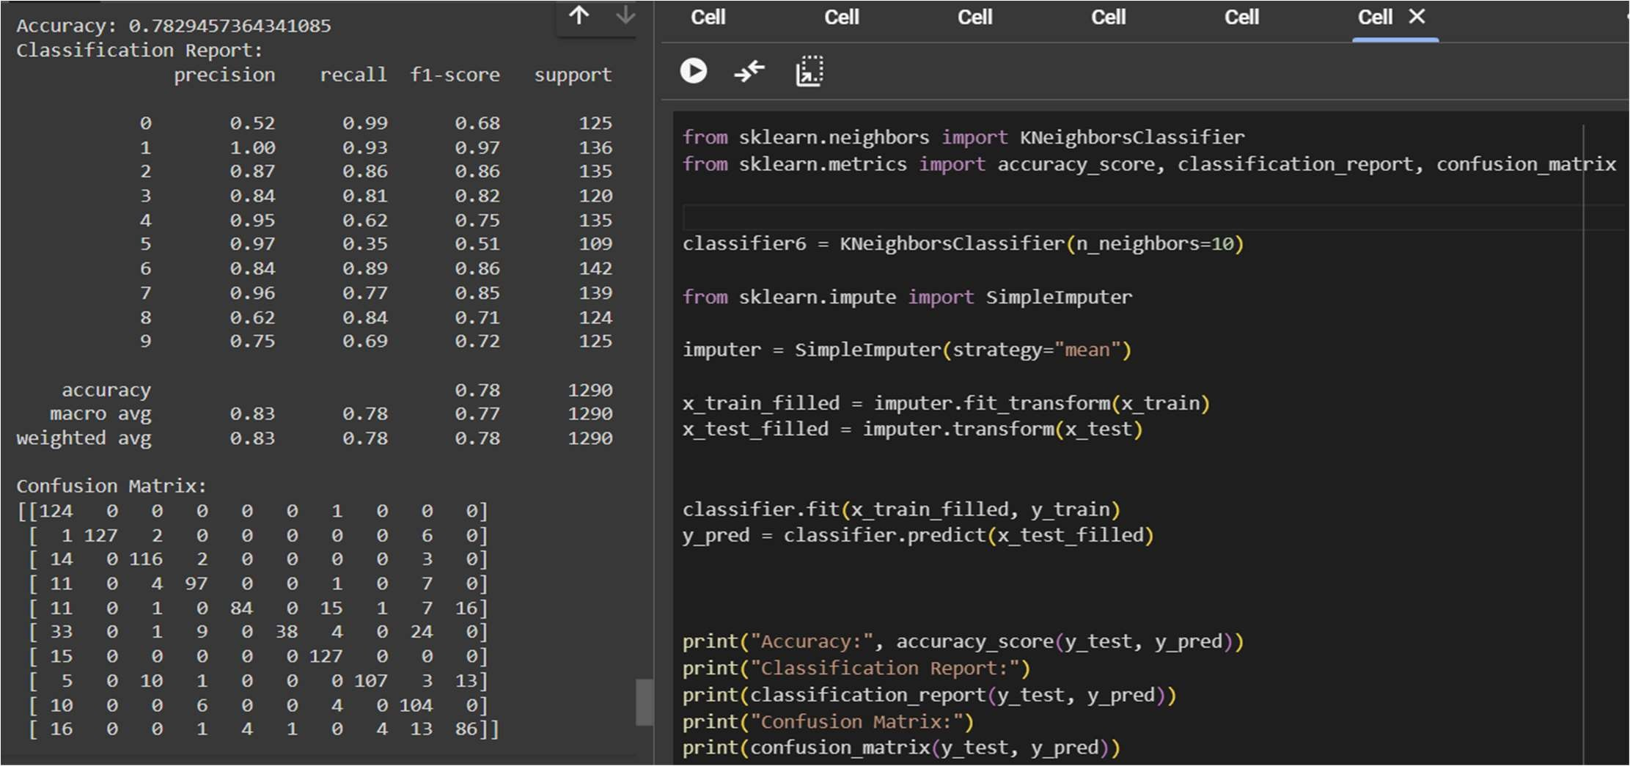

TEST_SIZE=0.10 AND TRAIN_SIZE=0.90

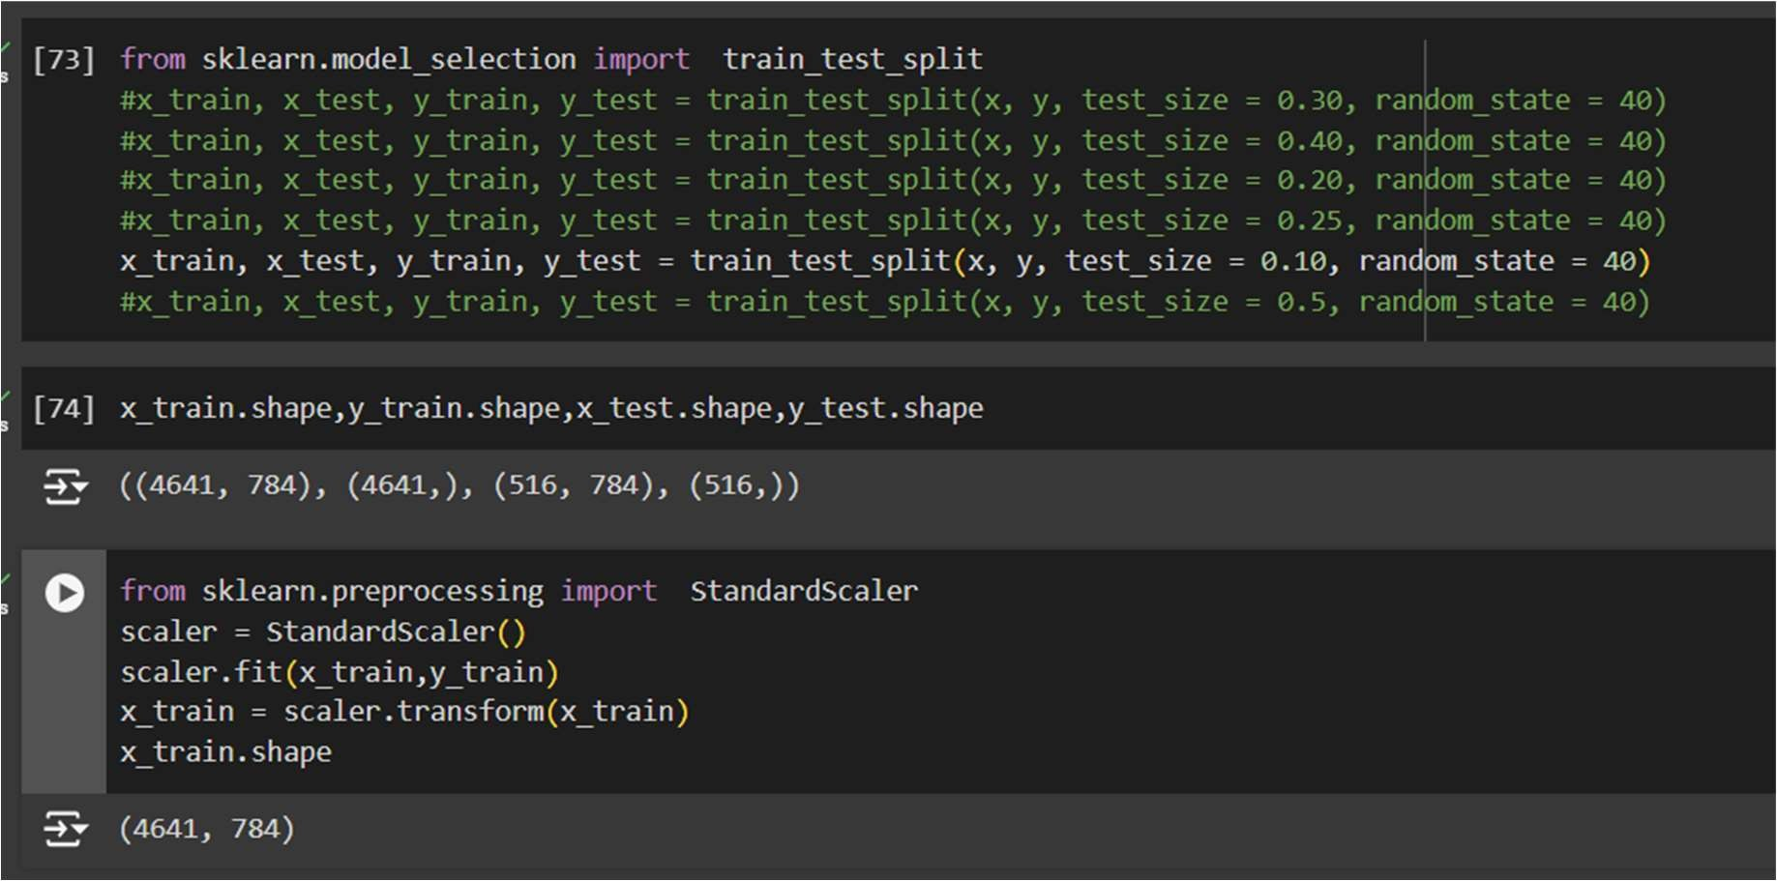

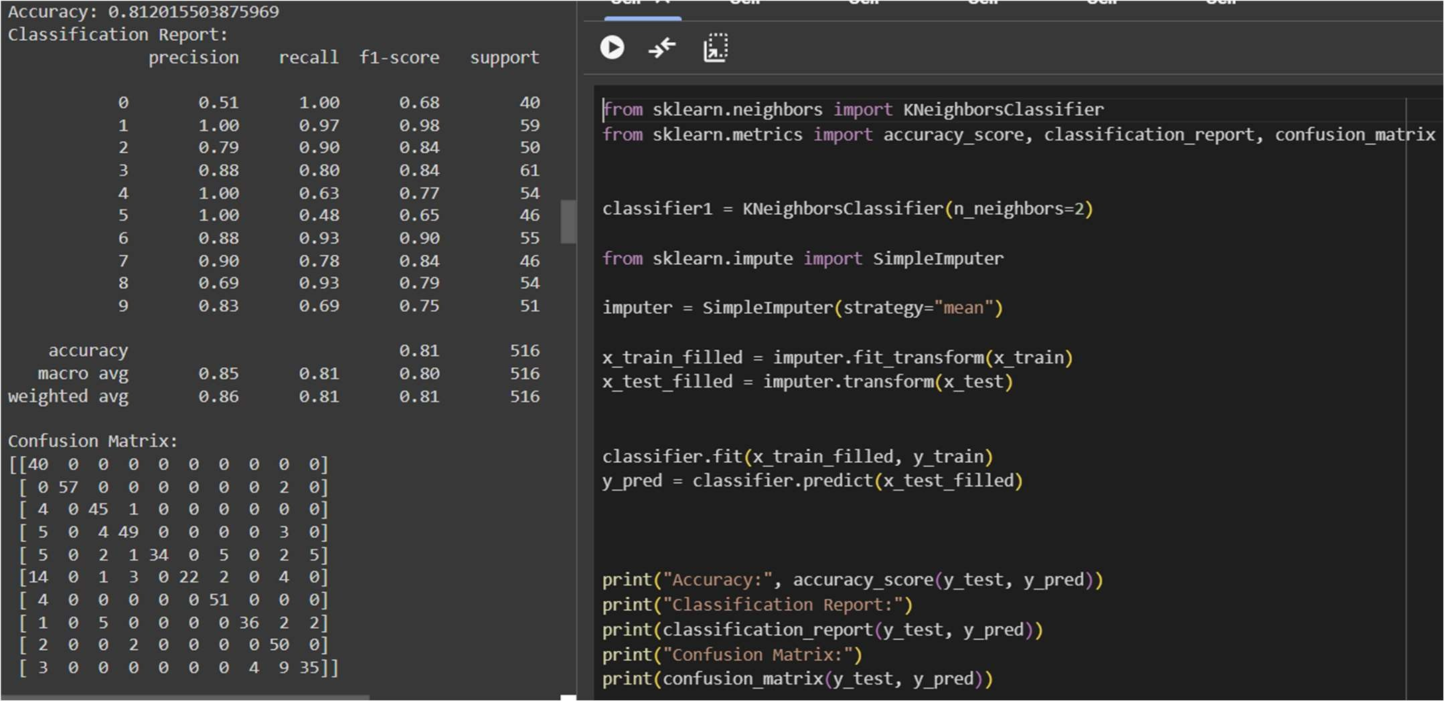

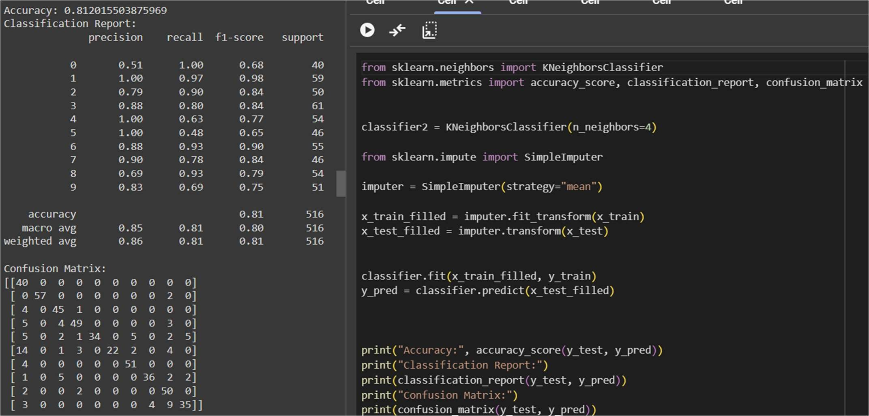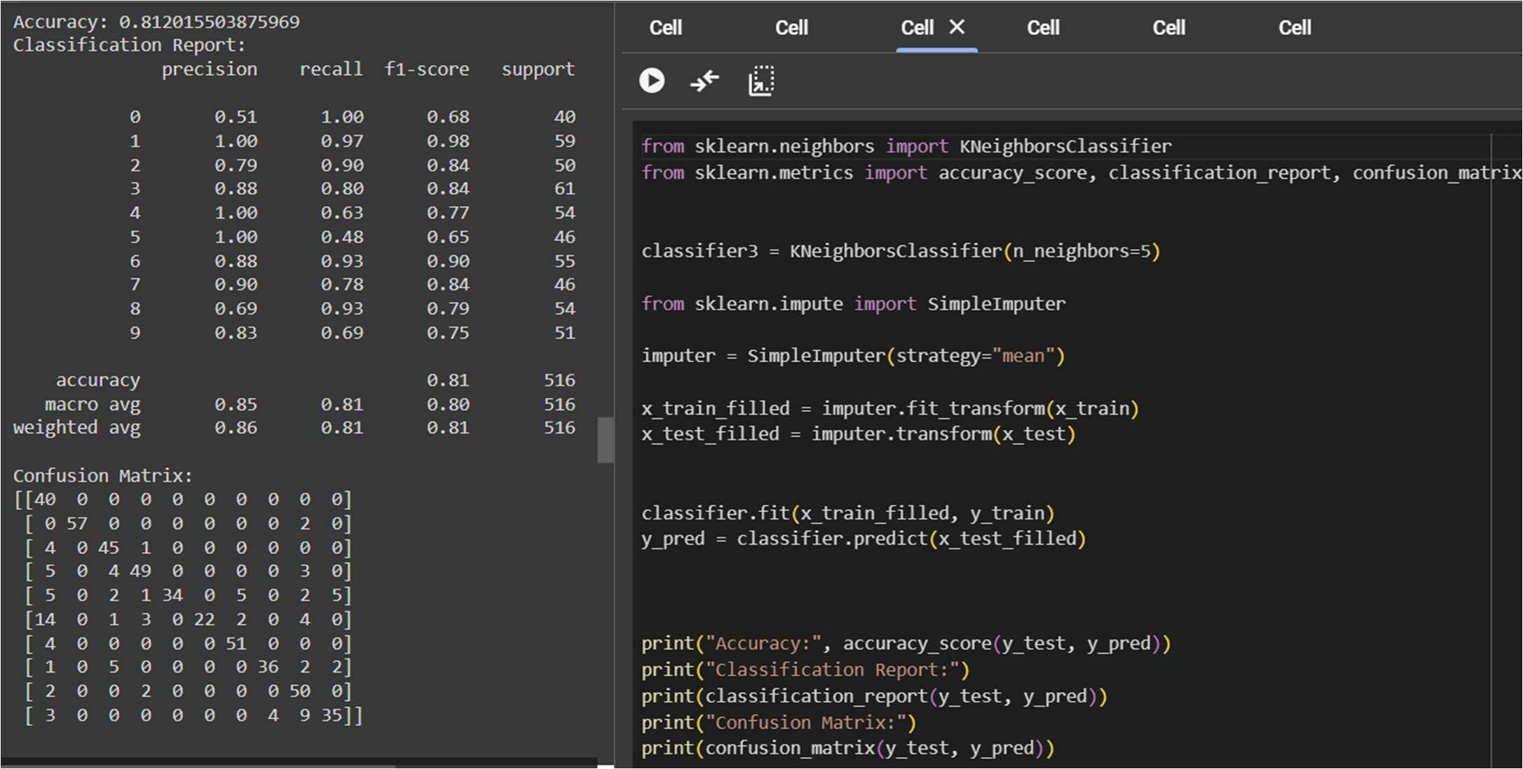

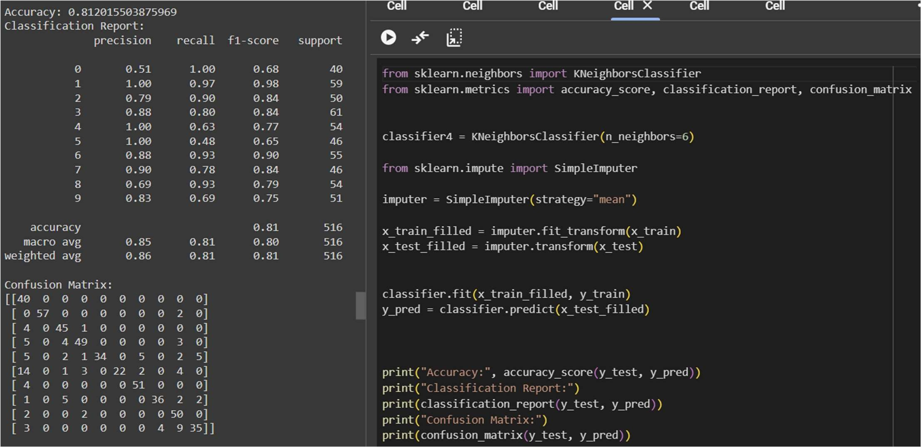

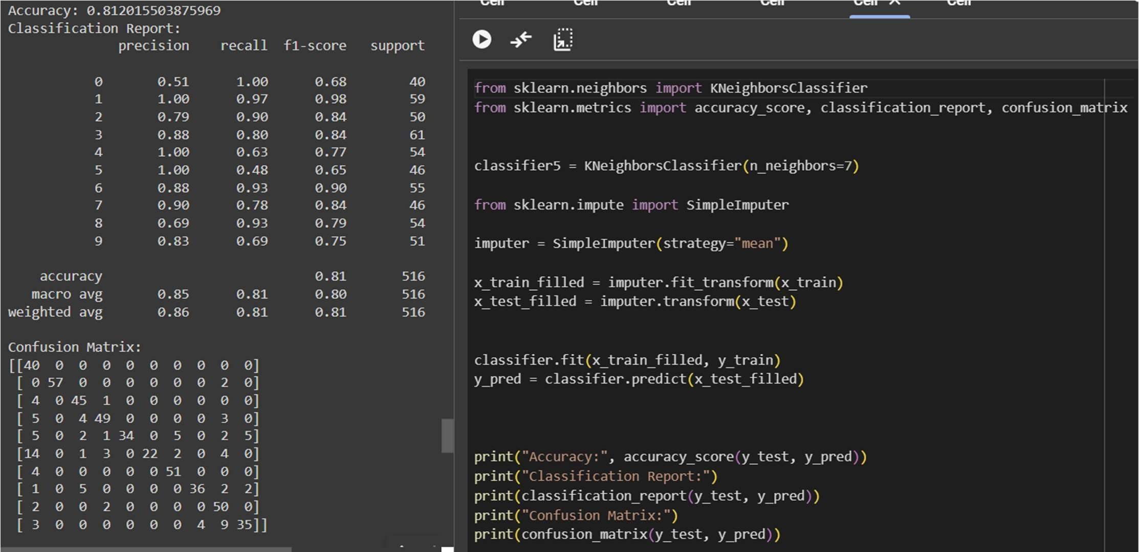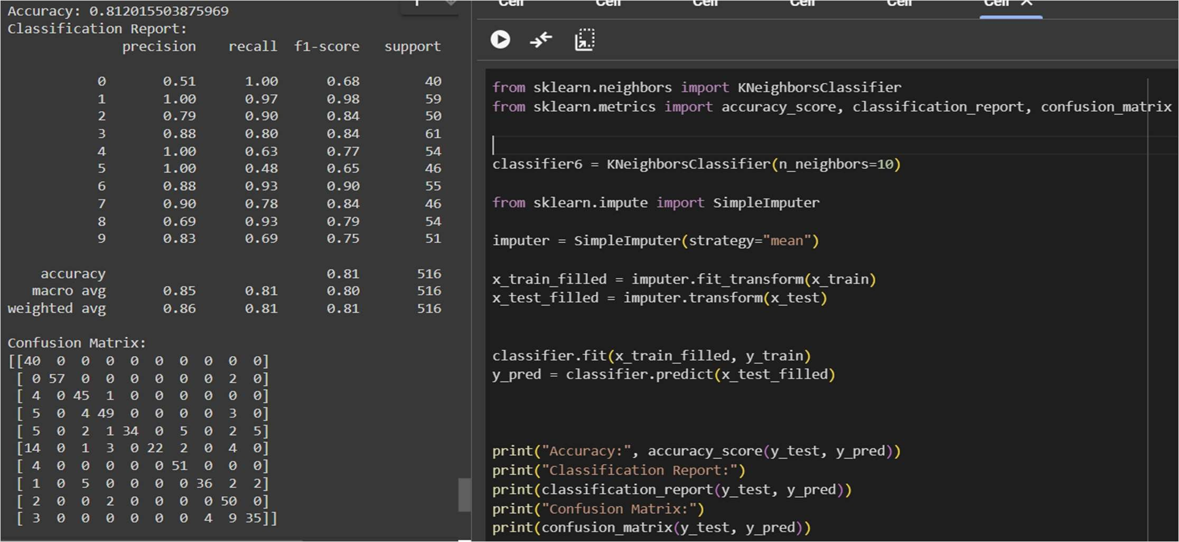

TEST_SIZE=0.05 AND TRAIN_SIZE=0.95

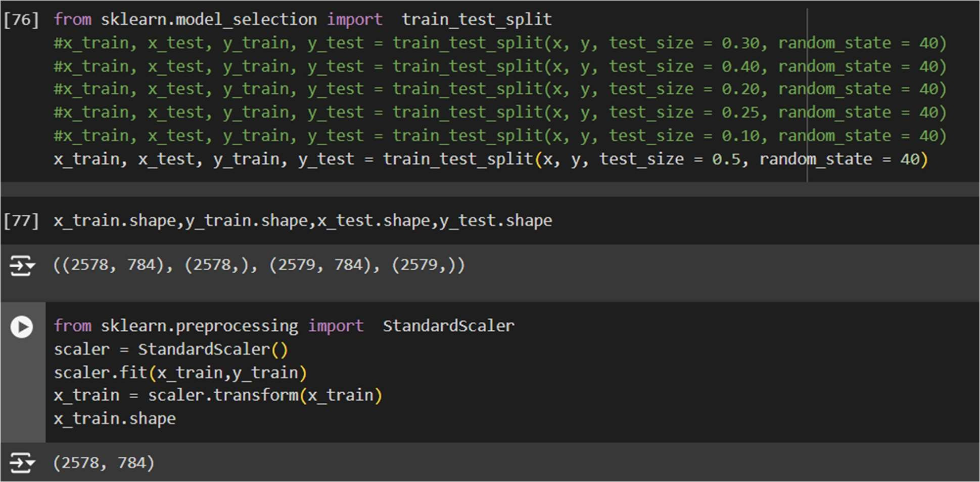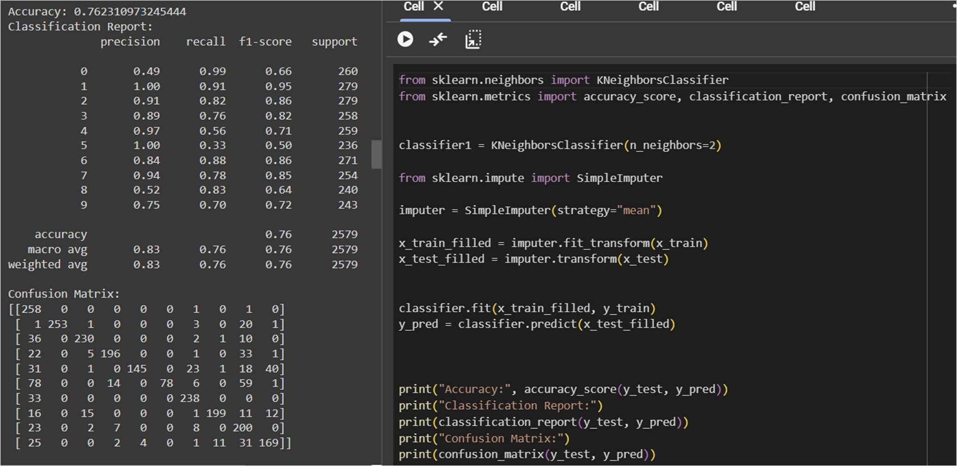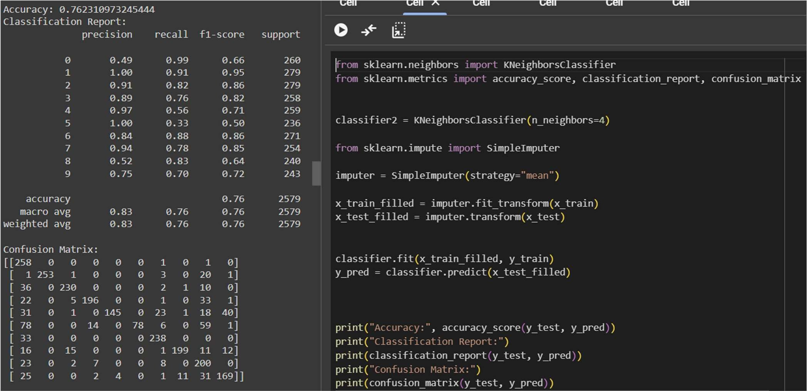

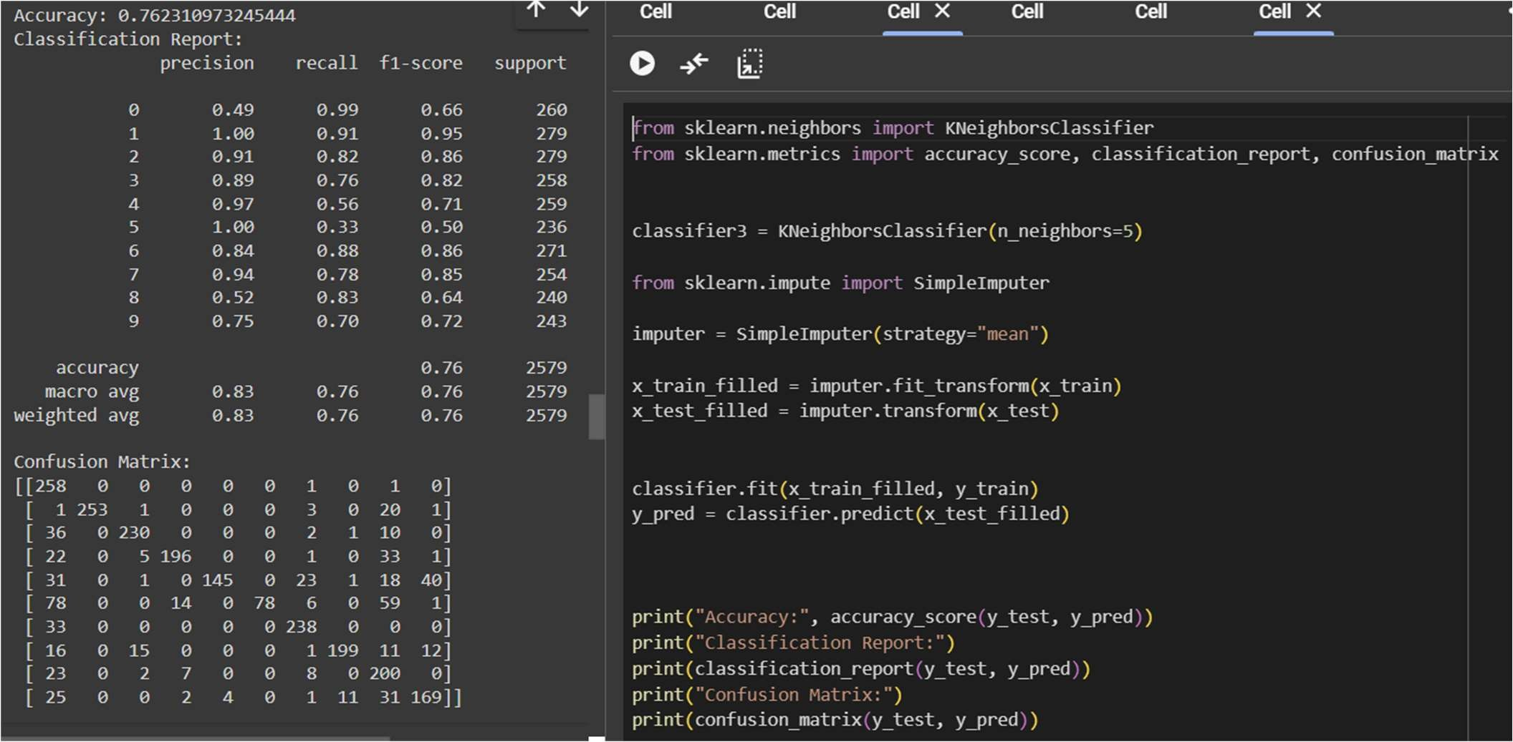

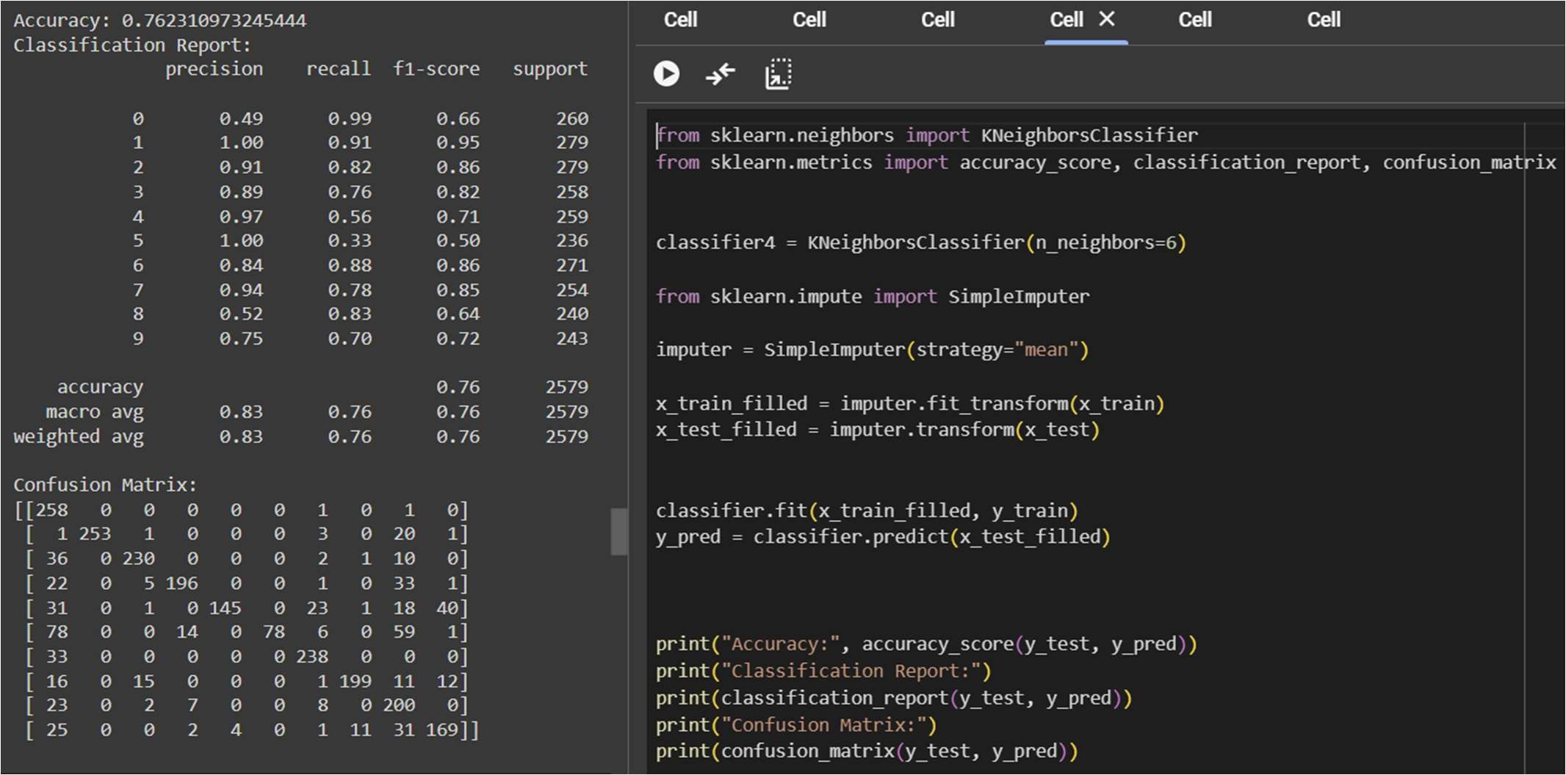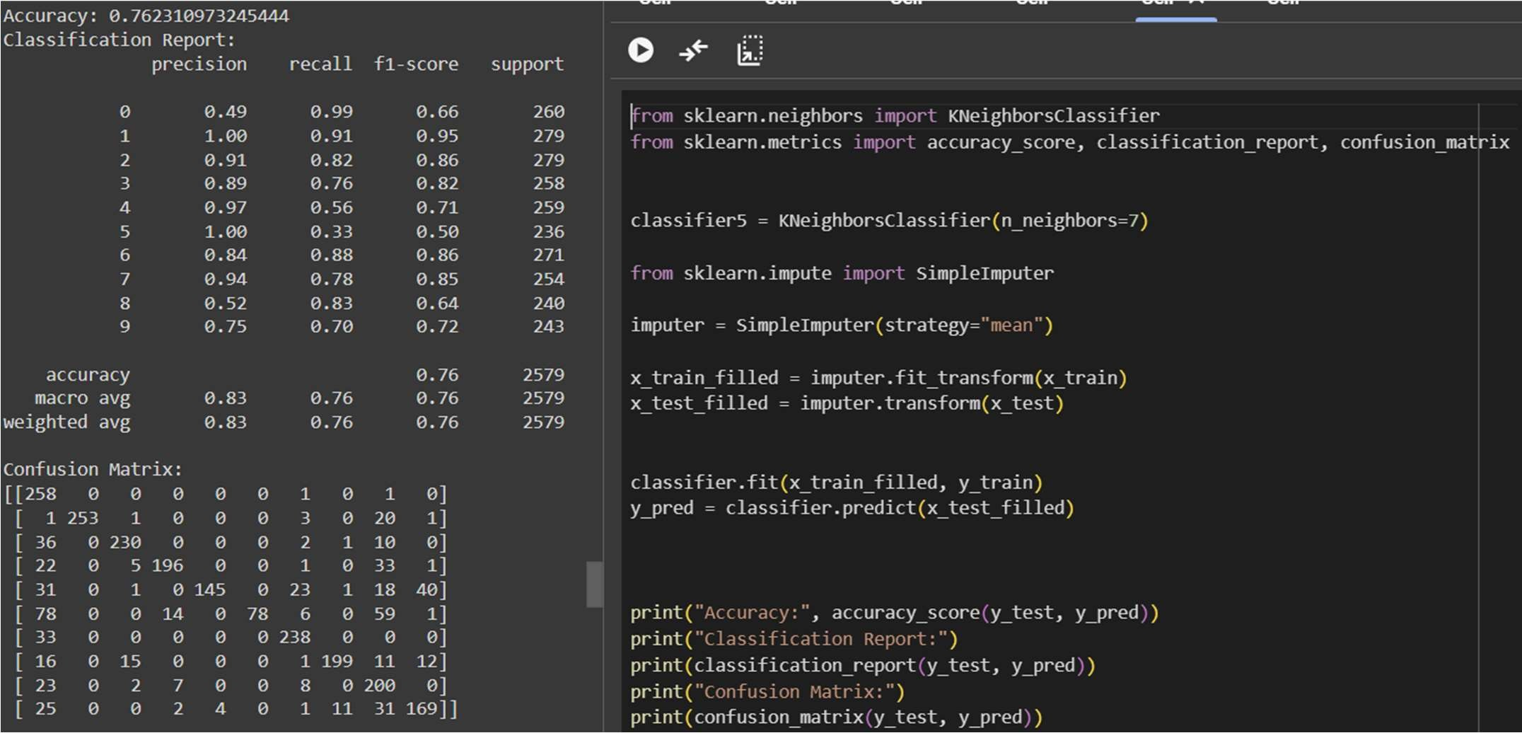

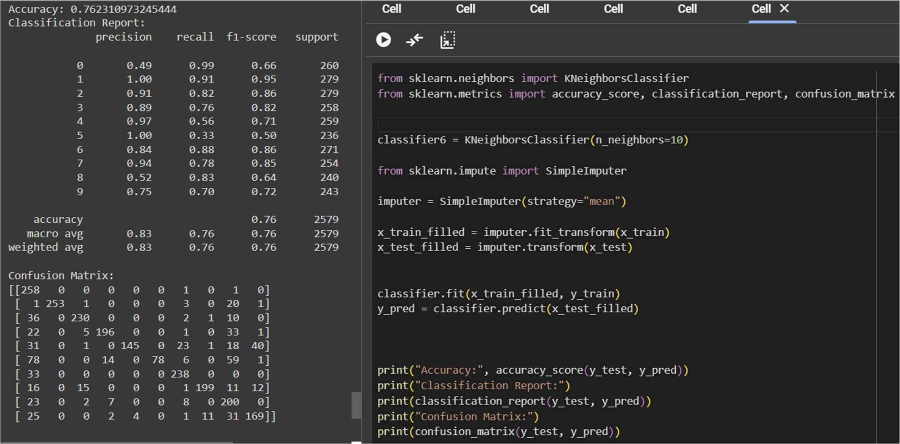

The performance of the KNN model is influenced by both the training-testing split and the k value:

Training-Testing Split: Larger training sets generally improve accuracy but can lead to overfitting. Smaller sets may underfit. Finding the right balance (e.g., 70:30, 80:20) is crucial for optimal performance.

k Value: Choosing k involves balancing bias and variance. Lower k values (e.g., 2) can overfit, while higher values (e.g., 10) may underfit. Experimentation helps find the optimal k that maximizes accuracy and generalization.

Optimization: Iteratively adjusting both parameters based on accuracy, precision, recall, and F1-score metrics ensures the KNN model performs well across different datasets and scenarios.